

GMS/

**Teva – Project Customization Document**

**HIP**

Polaris Solutions  
17-FEB-2017

100 Broadway 7th Floor  
New York, New York 10005

Table of Contents

1. Purpose 9

2. Scope 9

3. Assumptions 9

4. Project Customizations 12

4.1 System Global Changes and Workflow changes 12

4.1.1 Business Requirement Changes 12

4.1.2 Technical Customizations 12

Page Level Customizations 12

Technical Specification Changes 12

4.1.3 Wireframes 13

4.2 Inbox 13

4.2.1 Business Requirement Changes 13

4.2.2 Technical Customizations 13

Page Level Customizations 13

Technical Specification Changes 13

4.2.3 Wireframes 13

4.3 Activity Overview 15

4.3.1 Business Requirement Changes 15

4.3.2 Technical Customizations 15

Page Level Customizations 15

Technical Specification Changes 16

4.3.3 Wireframes 16

4.4 General 17

4.4.1 Business Requirement Changes 17

4.4.2 Technical Customizations 17

Page Level Customizations 17

Technical Specification Changes 19

4.4.3 Wireframes 19

4.5 Activity Category – Third Party Service Retention 21

4.5.1 Business Requirement Changes 21

4.5.2 Technical Customizations 21

Page Level Customizations 21

Technical Specification Changes 26

4.5.3 Wireframes 27

4.6 Activity Category – Teva Sponsored Research/Collaborative Research 29

4.6.1 Business Requirement Changes 29

4.6.2 Technical Customizations 30

Page Level Customizations 30

Technical Specification Changes 31

4.6.3 Wireframes 31

4.7 Activity Category – Educational Sponsorships 31

4.7.1 Business Requirement Changes 31

4.7.2 Technical Customizations 32

Page Level Customizations 32

Technical Specification Changes 33

4.7.3 Wireframes 33

4.8 Activity Category- Advisory Board/ Expert Meeting Activity 34

4.8.1 Business Requirements Changes 34

4.8.2 Technical Customizations 35

Page Level Customizations 35

Technical Specification Changes 40

4.8.3 Wireframes 40

4.9 Activity Category- Items/Gifts Activity 41

4.9.1 Business Requirements Changes 41

4.9.2 Technical Customizations 42

Page Level Customizations 42

Technical Specification Changes 43

4.9.3 Wireframes 43

4.10 Activity Category- Hospitality Activity 44

4.10.1 Business Requirements Changes 44

4.10.2 Technical Customizations 44

Page Level Customizations 44

Technical Specification Changes 47

4.10.3 Wireframes 48

4.11 Activity Category- Sponsorship of Third Party Event/ Activity 48

4.11.1 Business Requirements Changes 48

4.11.2 Technical Customizations 49

Page Level Customizations 49

Technical Specification Changes 50

4.11.3 Wireframes 51

4.12 Activity Category- Community Donation 51

4.12.1 Business Requirements Changes 51

4.12.2 Technical Customizations 52

Page Level Customizations 52

Technical Specification Changes 53

4.12.3 Wireframes 54

4.13 Activity Category- Research Grants 54

4.13.1 Business Requirements Changes 54

4.13.2 Technical Customizations 55

Page Level Customizations 55

Technical Specification Changes 56

4.13.3 Wireframes 56

4.14 Activity Category- Corporate Membership 57

4.14.1 Business Requirements Changes 57

4.14.2 Technical Customizations 57

Page Level Customizations 58

Technical Specification Changes 59

4.14.3 Wireframes 59

4.15 Activity Category- Educational Grants/Scholarships 60

4.15.1 Business Requirements Changes 60

4.15.2 Technical Customizations 60

Page Level Customizations 61

Technical Specification Changes 62

4.15.3 Wireframes 62

4.16 Activity Category- Equipment/Product Donation 63

4.16.1 Business Requirements Changes 63

4.16.2 Technical Customizations 63

Page Level Customizations 64

Technical Specification Changes 65

4.16.3 Wireframes 65

4.17 Activity Category- Patient Support 66

4.17.1 Business Requirements Changes 66

4.17.2 Technical Customizations 67

Page Level Customizations 67

Technical Specification Changes 71

4.17.3 Wireframes 71

4.18 Activity Category- Speaker Programs 73

4.18.1 Business Requirements Changes 73

4.18.2 Technical Customizations 73

Page Level Customizations 73

Technical Specification Changes 74

4.18.3 Wireframes 74

4.19 Activity Category- Site Visit 75

4.19.1 Business Requirements Changes 75

4.19.2 Technical Customizations 75

Page Level Customizations 76

Technical Specification Changes 77

4.19.3 Wireframes 77

4.19.4 Activity Category- Market Research 78

4.19.5 Business Requirements Changes 78

4.19.6 Technical Customizations 78

Page Level Customizations 78

Technical Specification Changes 81

4.19.7 Wireframes 82

4.20 Grants and Donations 85

4.20.1 Business Requirements Changes 85

4.20.2 Technical Customizations 85

Page Level Customizations 86

Technical Specification Changes 86

4.20.3 Wireframes 86

4.21 Activity Category – MSA (HIDDEN) 86

4.21.1 Business Requirements Changes 86

4.22 Activity Information 86

4.22.1 Business Requirements Changes 86

4.22.2 Technical Customizations 86

Page Level Customizations 86

Technical Specification Changes 89

4.22.3 Wireframes 90

4.23 Nominations 93

4.23.1 Business Requirements Changes 93

4.23.2 Technical Customizations 93

Page Level Customizations 93

Technical Specification Changes 96

4.23.3 Wireframes 97

4.24 Fair Market Value 99

4.24.1 Business Requirements Changes 99

4.24.2 Technical Customizations 100

Page Level Customizations 100

Technical Specification Changes 100

4.24.3 Wireframes 100

4.25 Documents 100

4.25.1 Business Requirements Changes 100

4.25.2 Technical Customizations 100

Page Level Customizations 100

Technical Specification Changes 101

4.25.3 Wireframes 101

4.26 Contracting 101

4.26.1 Business Requirements Changes 101

4.27 Post-Event 102

4.27.1 Business Requirements Changes 102

4.27.2 Technical Customizations 102

Page Level Customizations 102

Technical Specification Changes 102

4.27.3 Wireframes 102

4.28 Approval 103

4.28.1 Business Requirements Changes 103

4.28.2 Technical Customizations 104

Page Level Customizations 104

Technical Specification Changes 104

4.28.3 Wireframes 105

4.29 Appendix A 105

4.29.1 Business Requirements Changes 105

4.29.2 Activity Category Mapping 106

5. Non-functional system Requirements 107

Revision History 108

Glossary 109

Signatures 110

## Purpose

The purpose of this document is to specify the customizations made to the Polaris HIP as per Teva’s requirements. The document aims to provide all essential information needed for the user to fully understand the scope of the customizations and how they will be implemented.

## Scope

Teva is implementing a global instance of HIP, emphasizing an out of the box approach with minimal changes. Roll out will be to 55 countries in 14 languages. There are ~20 different activity types. Certain activity types will have will have activity category specific questions which replace some of the questions normally found in the general tab. Teva will not perform contracting in HIP, so that module will be hidden and the workflow adjusted to route around it. A document repository and reference sheet will be used by Teva to allow proper documentation to be uploaded based on the activity type. AOP functionality will also be disabled. Cross-border transaction functionality being developed as part of HIP 3.3 will be used in the Teva HIP implementation as well.

## Assumptions

* Effort for the project is based upon the following scope
  + HIP –
    - 55 Countries
      * EU
        + Denmark
        + Czech Republic
        + Slovakia
        + Hungary
        + Slovenia
        + Italy
        + Croatia
        + Portugal
        + Netherlands
        + Poland
        + Serbia
        + Austria
        + Romania
        + Latvia
        + Lithuania
        + Bosnia
        + Spain
        + Switzerland
        + Germany
        + UK
        + Belgium
        + Bulgaria
        + Greece
        + Macedonia
        + Norway
        + Sweden
        + France
        + Estonia
        + Finland
        + Malta
        + Iceland
      * Growth Markets (formerly EMIA-APAC)
        + Russia
        + Ukraine
        + Kazakhstan
        + Israel
        + South Africa
        + Turkey
        + Japan
        + Thailand
        + India
        + Korea
        + Singapore
        + China
        + Indonesia
        + Australia
        + Ireland
      * LATAM
        + Mexico
        + Argentina
        + Brazil
        + Chile
        + Peru
        + Uruguay
        + Venezuela
      * North America
        + United States
        + Canada
    - Standard Workflows: *Advisory Board, Consulting, Grants and Donations*
    - Activity Types:
      * Following the Advisory board workflow
        + Fee for service
        + Advisory Board/ Expert Meeting
        + Sponsorship of third party event
        + Educational sponsorships
        + Scientific/ Investigator meeting
        + Speaker program
        + Site visit
      * Following the Consulting workflow
        + Teva sponsored research activities
        + Market research
      * Following the Grants and Donations workflow
        + Research grants
        + Corporate membership
        + Educational grant/scholarship
        + Hospitality
        + Items/gifts
        + Community donations
        + Equipment donation/ product donation
        + Patient support
        + Third party service retention

|  |  |  |  |  |  |  |  |  |  |  |  |  |  |  |
| --- | --- | --- | --- | --- | --- | --- | --- | --- | --- | --- | --- | --- | --- | --- |
| **Activity Type** | Workflow | Activity Overview | General | Activity Category | Activity Info | Activity Approval | Nomination | FMV | Documents | Nomination Approval | Pre-Event Letters | Closeout Document | Activity Close-out | Post-Event Letters |
| Fee for Service | Ad Board | x | x |  | x | x | x | x | x | x |  | x | x |  |
| Advisory Board/Expert Meeting | Ad Board | x | x | x | x | x | x | x | x | x |  | x | x |  |
| Sponsorship of Third Party Event | Ad Board | x | x | x | x | x | x | x | x | x |  | x | x |  |
| Educational Sponsorships | Ad Board | x | x | x | x | x | x | x | x | x |  | x | x |  |
| Scientific/Investigator Meeting | Ad Board | x | x |  | x | x | x | x | x | x |  | x | x |  |
| Speaker Program | Ad Board | x | x | x | x | x | x | x | x | x |  | x | x |  |
| Site Visit | Ad Board | x | x | x | x | x | x | x | x | x |  | x | x |  |
| Teva Sponsored Research Activities | Consulting | x | x | x |  |  | x | x | x | x |  | x | x |  |
| Market Research | Consulting | x | x | x |  |  | x | x | x | x |  | x | x |  |
| Research Grants | Grants and Donations | x | x | x |  |  | x |  | x | x |  | x | x |  |
| Corporate Membership | Grants and Donations | x | x | x |  |  | x |  | x | x |  | x | x |  |
| Educational Grant / Scholarship | Grants and Donations | x | x | x |  |  | x |  | x | x |  | x | x |  |
| Hospitality | Grants and Donations | x | x | x |  |  | x |  | x | x |  | x | x |  |
| Items/Gifts | Grants and Donations | x | x | x |  |  | x |  | x | x |  | x | x |  |
| Community Donations | Grants and Donations | x | x | x |  |  | x |  | x | x |  | x | x |  |
| Equipment Donation / Product Donation | Grants and Donations | x | x | x |  |  | x |  | x | x |  | x | x |  |
| Patient Support | Grants and Donations | x | x | x |  |  | x |  | x | x |  | x | x |  |
| Third Party Service Retention | Grants and Donations | x | x | x |  |  | x |  | x | x |  | x | x |  |

* + - Languages: *English, Spanish, EU Spanish, Russian, German, French, French Canadian, Brazilian Portuguese, Japanese, Croatian, Bulgarian, Italian, Czech, Polish*
    - Out of scope: *Annual Operating Plans, Master Services Agreements, HCP Self-Service Portal*
  + Interfaces:
    - HCP/HCO Customer Master (single source)
      * Inbound interface to Polaris
      * US & O-US HCPs, HCOs, Non-HCP/Os
    - Single Sign On (SSO)
      * Single sign on for employee authentication (specific technology will be addressed as part of Interface spec)
      * Access will be through Polaris Global Compliance Portal (GCP)

## Project Customizations

### System Global Changes and Workflow changes

#### Business Requirement Changes

|  |  |
| --- | --- |
| Original BR ID | Description |
| GLO-BR-01 | Contracting will not be performed in HIP, therefore the contracting module needs to be turned off and the workflow adjusted |
| GLO-BR-02 | AOP functionality will be turned off, all AOP modules, user groups, roles, and admin functionality will be removed |
| GLO-BR-03 | Activity types to be filtered based on country so certain activity types that aren’t permissible in that country aren’t shown (e.g., items/gifts) (Refer to Appendix A at end of document for mapping) |
| GLO-BR-04 | All free text fields will have field lengths of 2000 characters unless otherwise noted |
| GLO-BR-05 | All mentions of AOP within the Administrator module to be hidden |
| GLO-BR-06 | All mentions of MSA within the Administrator module to be hidden |
| GLO-BR-07 | All mentions of Contracting within the Administrator module to be hidden |

#### Technical Customizations

##### Page Level Customizations

|  |  |  |  |  |
| --- | --- | --- | --- | --- |
| Attribute Type | Title | Description | Validation | Customization |
|  |  |  |  |  |

##### Technical Specification Changes

|  |  |  |  |
| --- | --- | --- | --- |
| BR ID | TR ID | Section Reference | Customization Description |
|  |  |  |  |

#### Wireframes

### Inbox

#### Business Requirement Changes

|  |  |
| --- | --- |
| Original BR ID | Description |
|  |  |

#### Technical Customizations

##### Page Level Customizations

|  |  |  |  |  |
| --- | --- | --- | --- | --- |
| Attribute Type | Title | Description | Validation | Customization |
| Page Feature | Remove Contracting Tab from Inbox for all users | Remove Tab |  | Remove |

##### Technical Specification Changes

|  |  |  |  |
| --- | --- | --- | --- |
| BR ID | TR ID | Section Reference | Customization Description |
|  |  |  |  |

#### Wireframes

Submitter:

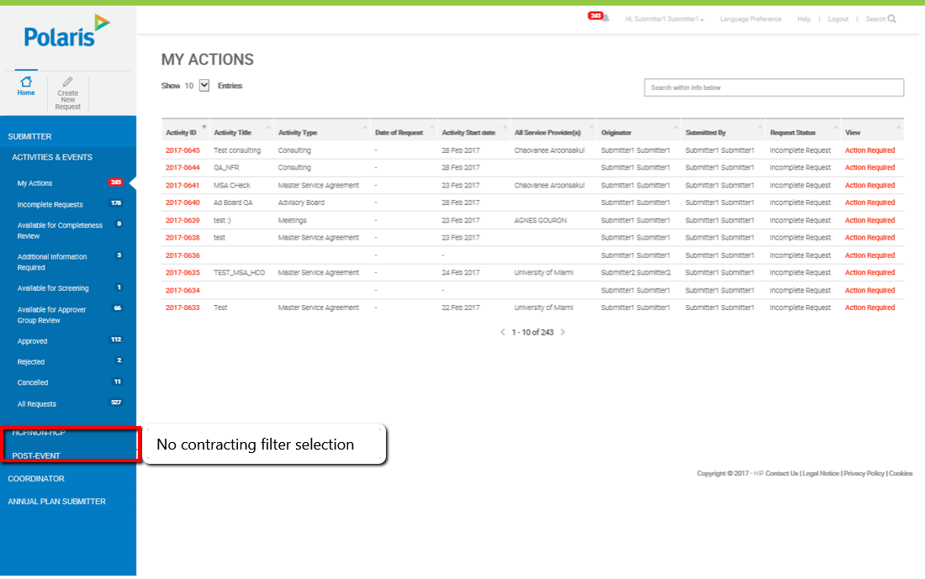

Coordinator:

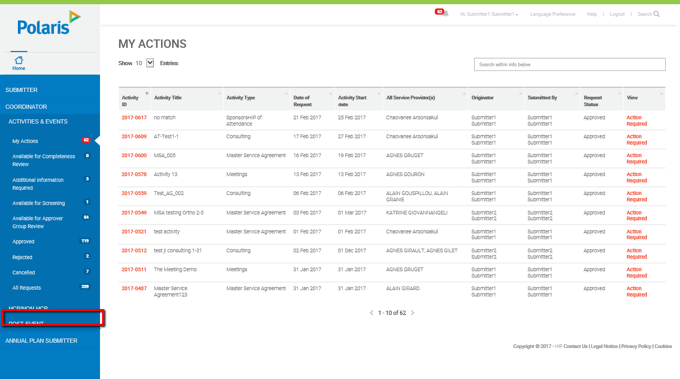

Approver:

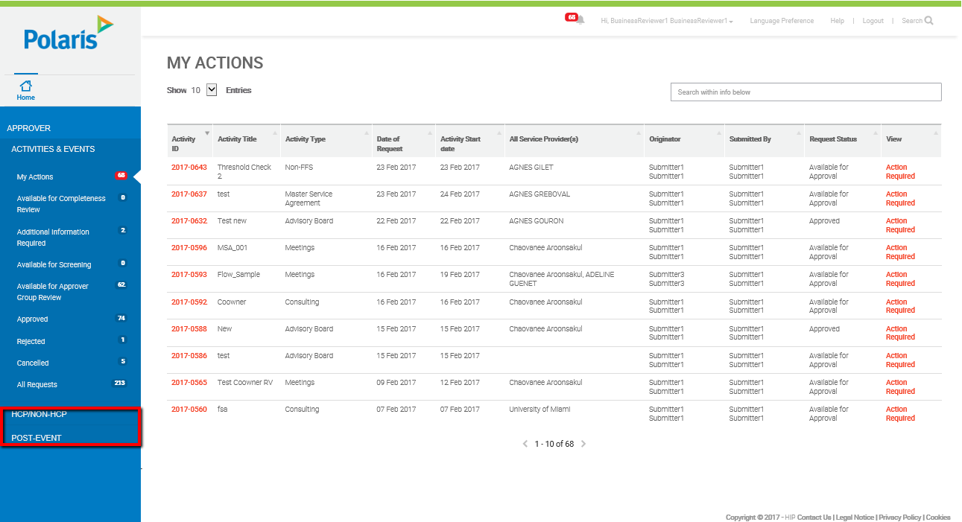

### Activity Overview

#### Business Requirement Changes

|  |  |
| --- | --- |
| Original BR ID | Description |
|  |  |
|  |  |

#### Technical Customizations

##### Page Level Customizations

|  |  |  |  |  |
| --- | --- | --- | --- | --- |
| Attribute Type | Title | Description | Validation | Customization |
| Data Capture | I hereby certify that I am trained on the appropriate Polaris policies and procedures that are required to conduct engagements with the Service Provider(s) | Reword check box to table in validation “ | * Field Label: “I have reviewed Teva’s Code of Conduct, Compliance Principles, Policy on the Prevention of Corruption, applicable function, regional or local policies / SOPs, and any other company standards relating to this activity (e.g., travel requirements, meal and gift limits, due diligence procedures).   I certify that the proposed activity is for a legitimate purpose, and is in compliance with Teva standards and applicable laws and codes.  I affirm that this submission and supporting documentation are accurate and complete.”   * Required: Yes * Validation: Use Default | Rename |
| Data Capture | Country of Requestor | Rename field Transaction owner country to “Country of Requestor” | * Field Control: Drop-down, ordered alphabetically * List: Country List * Required: Yes * Validation: Once picked and the Activity Overview section is complete, this selection is locked. * Help text: Please select the appropriate country the submitter is from | Rename |
| Data Capture | Are there any Co-owners for this activity? | Remove field and its preceding related fields | * Field Control: Yes/No Radio Button | Remove |
| Data Capture | Cost Center/Project Code: | Remove field and its preceding related fields | * Field Control: Radio Button | Remove |
| Data Capture | Disease State: | Remove field | * Field Control: Multi-select list | Remove |
| Data Capture | Please State | Add New Field | * Field Control: Free Text Box * Required: Yes * Position: Below “Product” field * Validation: This field should only be displayed if “Other” is selected under “Product” | New |

##### Technical Specification Changes

|  |  |  |  |
| --- | --- | --- | --- |
| BR ID | TR ID | Section Reference | Customization Description |
|  |  |  |  |

#### Wireframes

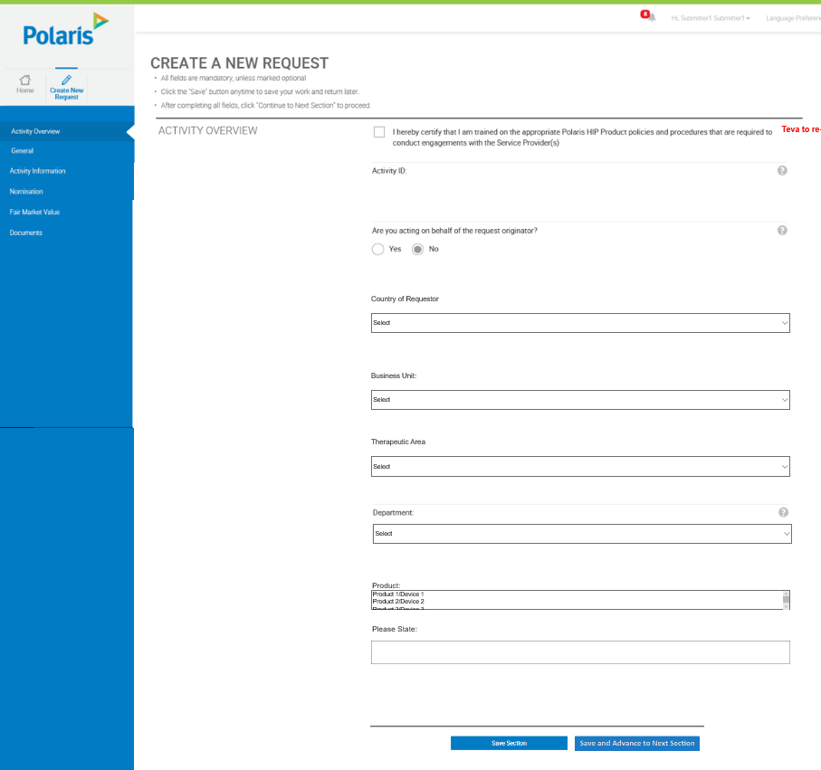

### General

#### Business Requirement Changes

|  |  |
| --- | --- |
| Original BR ID | Description |
| BR-GEN-01 | Filter Activity Types based on selection of Activity Country in this section |

#### Technical Customizations

##### Page Level Customizations

|  |  |  |  |  |
| --- | --- | --- | --- | --- |
| Attribute Type | Title | Description | Validation | Customization |
| Data Capture | Expected Deliverables/ Outcome | Add new field “Expected Deliverables/Outcome” | * Field Control: Free text box * Required: Yes * Position: Below “Main Objective(s)” * Validation: Field must have text in it * Help text: What deliverables, outcomes or benefits does Teva expect to receive as part of this activity? * Field Length: 2000 characters | New |
| Data Capture | Is anyone affiliated with the request a Government Official? | Add new field “Is anyone affiliated with the request a Government Official?” | * Field Control: Yes/No Radio Button * Required: Yes * Position: Below “Expected Deliverables/Outcome” * Validation: Yes or No must be selected * Help text: “Please Explain” free text box should be displayed when user selects “Yes” | New |
| Data Capture | Please Explain | Display field “Please Explain” | * Field Control: Free text box * Required: Yes, if Yes is selected for “ Is anyone affiliated with the request a Government Official?”, otherwise no * Field Format: Alphanumeric * Position: Below “Is anyone affiliated with the request a Government Official?” * Validation: This field should be displayed on when “Yes” is selected for “Is anyone affiliated with the request a Government Official?” * Field length: 2000 characters | New |
| Data Capture | Activity Country | Activity country will lock upon selection of “Save and Advance” | * Validation: Field will no longer be changeable once “Save and Advance” is selected | Validation Change |
| Data Capture | Activity Category | Rename Activity Category to Activity Type | * Field Label: Activity Type | Rename |
| Data Capture | Sub Category | Remove Field | * Field control: drop down | Remove |
| Data Capture | Selection criteria & rationale for the Service Provider: | Remove field | * Field Control: Text field | Remove |
| Data Capture | Service Provider scope of service: | Remove field | * Field Control: Text field | Remove |
| Data Capture | Describe the activity materials that will be provided, including the pre-activity: | Remove field | * Field Control: Text field | Remove |
| Data Capture | Are there advisors/consultants currently under contract to provide the required information to adequately address the business need stated above? | Remove field and preceding related fields | * Field Control: Yes/No Radio button | Remove |
| Data Capture | Please select the Polaris contracting entity for this activity: | Remove field | * Field Control: Drop-down | Remove |
| Data Capture | Choose an appropriate option for the Annual Operating Plan (AOP): | Remove field and preceding related fields | * Field Control: Drop-down | Remove |
| Data Capture | Currency | Remove field | * Field Control: Dropdown | Remove |
| Data Capture | Total estimated amount | Remove Field | * Field Control: Numeric text box | Remove |

##### Technical Specification Changes

|  |  |  |  |
| --- | --- | --- | --- |
| BR ID | TR ID | Section Reference | Customization Description |
|  |  |  |  |

#### Wireframes

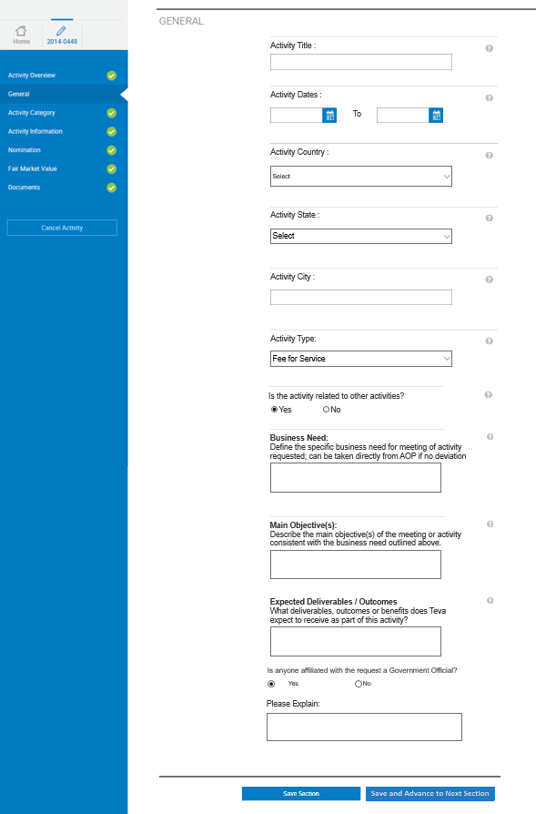

### Activity Category – Third Party Service Retention

#### Business Requirement Changes

|  |  |
| --- | --- |
| Original BR ID | Description |
| BR-TPS-001 | The request will follow the base grants and donations workflow |
| BR-TPS-002 | The customizations should be added to the base grants and donations request - activity category form |

#### Technical Customizations

##### Page Level Customizations

|  |  |  |  |  |
| --- | --- | --- | --- | --- |
| Attribute Type | Title | Description | Validation | Customization |
| Data Capture | What Teva entity is the appointment for? | Add new field - What Teva entity is the appointment for? | * Field Control: Text box * Required: Yes * Validation: Field must have text in it * Field length: 2000 characters | New |
| Data Capture | What countries/territories will the appointment cover? | Add new field - What countries/territories will the appointment cover? | * Field Control: Multi-select Drop-down * Required: Yes * Validation: At least one country must be selected | New |
| Data Capture | Please select the type of services to be provided | Add new field – Please select the type of services to be provided | * Field Control: Multi-select Drop-down * Required: Yes * Validation: At least one service must be selected | New |
| Data Capture | Please Explain | Add new field – Please Explain | * Field Control: Free Text box * Required: Yes * Validation: This field will only appear if “Other” is selected for “Please select the type of services to be provided” | New |
| Data Capture | Explain in detail why this appointment is required | Add field - Explain in detail why this appointment is required | * Field Control: Free text box * Required: Yes * Validation: Field must have text in it * Field length: 2000 characters | New |
| Data Capture | What is the proposed term of the appointment? | Add new field - What is the proposed term of the appointment? | * Field Control: Text box * Required: Yes * Validation: Field must have text in it * Field length: 2000 characters | New |
| Data Capture | What are the Candidates qualifications to fill this role? | Add new field - What are the Candidates qualifications to fill this role? | * Field Control: Text box * Required: Yes * Validation: Field must have text in it * Field length: 2000 characters | New |
| Data Capture | Has Teva previously appointed the Candidate to fill this role? | Add new field - Has Teva previously appointed the Candidate to fill this role? | * Field Control: Yes/No Radio button * Required: Yes * Validation: Yes or no must be selected | New |
| Data Capture | Please Explain | Display field “Please Explain” | * Field Control: Free text box * Required: Yes, if Yes is selected for “Has Teva previously appointed the Candidate to fill this role?”, otherwise no * Field Format: Alphanumeric * Position: Below “Has Teva previously appointed the Candidate to fill this role?” * Validation: This field should be displayed on when “Yes” is selected for “Has Teva previously appointed the Candidate to fill this role?” * Field length: 2000 characters | New |
| Data Capture | What is the expected fee arrangement? | Add new field - What is the expected fee arrangement? | * Field Control: Drop-down * List Values: Hourly, Not to Exceed, Total Contract Fee of, Other * Required: Yes * Validation: a non-blank option must be selected | New |
| Data Capture | Please Explain | Add new field – Please Explain | * Field Control: Free Text Box * Required: Yes * Validation: This field will only appear if “Other” is the value selected for “What is the expected fee arrangement?” | New |
| Data Capture | Commissions | Add new field - Commissions | * Field Control: Yes/No Radio button * Required: Yes * Validation: Yes or No must be selected | New |
| Data Capture | Please Explain | Display field “Please Explain” | * Field Control: Free text box * Required: Yes, if Yes is selected for “Previous Field”, otherwise no * Field Format: Alphanumeric * Position: Below “Commissions” * Validation: This field should be displayed on when “Yes” is selected for “Commissions” * Field length: 2000 characters | New |
| Data Capture | Will there be success payments or bonuses as part of this arrangement? | Add new field - Will there be success payments or bonuses as part of this arrangement? | * Field Control: Yes/No Radio button * Required: Yes * Validation: Yes or No must be selected | New |
| Data Capture | Please Explain | Display field “Please Explain” | * Field Control: Free text box * Required: Yes, if Yes is selected for “Previous Field”, otherwise no * Field Format: Alphanumeric * Position: Below “Success payments/bonuses” * Validation: This field should be displayed on when “Yes” is selected for “Success payments/bonuses” * Field length: | New |
| Data Capture | Will there be Advance Payments as part of this arrangement? | Add new field - Will there be Advance Payments as part of this arrangement? | * Field Control: Yes/No Radio button * Required: Yes * Validation: Yes or no must be selected | New |
| Data Capture | Please Explain | Display field “Please Explain” | * Field Control: Free text box * Required: Yes, if Yes is selected for “Previous Field”, otherwise no * Field Format: Alphanumeric * Position: Below “Advance Payments” * Validation: This field should be displayed on when “Yes” is selected for “Advance Payments” * Field length: 2000 characters | New |
| Data Capture | Is documentation of work performed required for payment? | Add new fields - Is documentation of work performed required for payment? | * Field Control: Yes/No Radio button * Required: Yes * Validation: Yes or no must be selected | New |
| Data Capture | Please Explain | Display field “Please Explain” | * Field Control: Free text box * Required: Yes, if No is selected for “Previous Field”, otherwise no * Field Format: Alphanumeric * Position: Below “Documentation of work performed required for payment?” * Validation: This field should be displayed on when “No” is selected for “Documentation of work performed required for payment?” * Field length: 2000 characters | New |
| Data Capture | Payment in local currency? | Add new field - Payment in local currency? | * Field Control: Yes/No Radio button * Required: Yes * Validation: Yes or no must be selected | New |
| Data Capture | Please Explain | Display field “Please Explain” | * Field Control: Free text box * Required: Yes, if No is selected for “Previous Field”, otherwise no * Field Format: Alphanumeric * Position: Below “Payment in local currency?” * Validation: This field should be displayed on when “No” is selected for “Payment in local currency?” * Field length: 2000 characters | New |
| Data Capture | Payment to be made to Candidates in-country bank account or  in-country mailing address? | Add new field - Payment to be made to Candidates in-country bank account or  in-country mailing address? | * Field Control: Yes/No Radio button * Required: Yes * Validation: Yes or no must be selected | New |
| Data Capture | Please Explain | Add new field - “Please Explain” | * Field Control: Free text box * Required: Yes, if No is selected for “Previous Field”, otherwise no * Field Format: Alphanumeric * Position: Below “Payment to be made to Candidates in-country bank account or in-country mailing address?” * Validation: This field should be displayed on when “No” is selected for “Payment to be made to Candidates in-country bank account or in-country mailing address?” * Field length: 2000 characters | New |
| Data Capture | Payment to be made by? | Add new field - Payment to be made by | * Field Control: Drop-down * Required: Yes * List Values: Check, Electronic Transfer, Other * Validation: A non-blank drop down option must be selected | New |
| Data Capture | Please Explain | Add new field - “Please Explain” | * Field Control: Free text box * Required: Yes, if Yes is selected for “Previous Field”, otherwise no * Field Format: Alphanumeric * Position: Below “Payment to be made by?” * Validation: This field should be displayed on when “Other” is selected for “Payment to be made by?” * Field length: 2000 characters | New |
| Data Capture | Does the fee include payment for reimbursement of expenses? | Add new field - Does the fee include payment for reimbursement of expenses | * Field Control: Yes/No Radio button * Required: Yes * Validation: Yes or no must be selected | New |
| Data Capture | Please Explain | Display field “Please Explain” | * Field Control: Free text box * Required: Yes, if Yes is selected for “Previous Field”, otherwise no * Field Format: Alphanumeric * Position: Below “Does the fee include payment for reimbursement of expenses?” * Validation: This field should be displayed on when “Yes” is selected for “Does the fee include payment for reimbursement of expenses?” * Field length: 2000 characters | New |
| Data Capture | Who will manage the contractual relationship with the Candidate?  Include name, title, phone and country | Add new field - Who will manage the contractual relationship with the Candidate?  Include name, title, phone and country | * Field Control: Free text box * Required: Yes * Validation: Field must include text | New |
| Data Capture | Please state the final disposition from the 3rd Party Group | Add new field – Please state the final disposition from the 3rd Party Group | * Field Control: Dropdown * Required: Yes * Validation: A non-blank dropdown option must be selected | New |

##### Technical Specification Changes

|  |  |  |  |
| --- | --- | --- | --- |
| BR ID | TR ID | Section Reference | Customization Description |
|  |  |  |  |

#### Wireframes

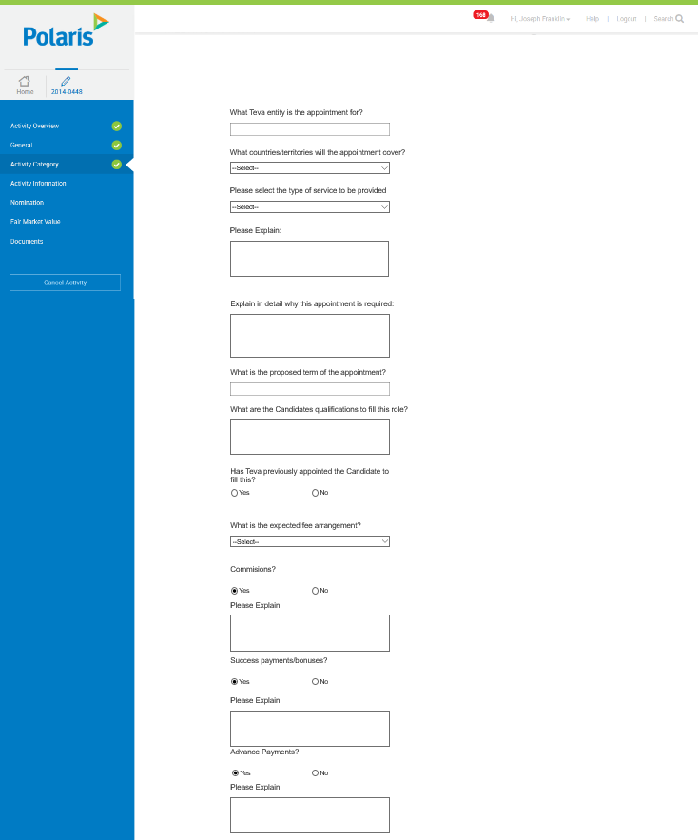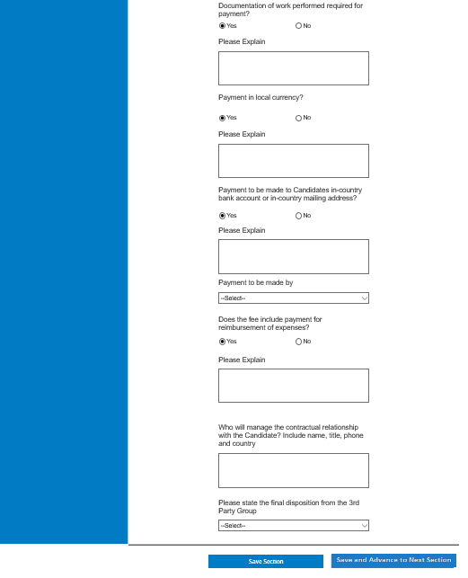

### Activity Category – Teva Sponsored Research/Collaborative Research

#### Business Requirement Changes

|  |  |
| --- | --- |
| Original BR ID | Description |
| BR-GDS-001 | The request will follow the base consulting workflow |
| BR-GDS-002 | The customizations should be added to the base consulting request - activity category form |

#### Technical Customizations

##### Page Level Customizations

|  |  |  |  |  |
| --- | --- | --- | --- | --- |
| Attribute Type | Title | Description | Validation | Customization |
| Data Capture | Purpose/Benefit of request | Rename field “Purpose” to “Purpose/Benefit of request” | * Field Format: Text box * Required: Yes * Validation: Use Default | Rename |
| Data Capture | Was the request solicited by Teva? | Add new field- Was the request solicited by Teva | * Field Format: Yes/No radio button * Position: Below Purpose/Benefit * Required: Yes * Validation: Yes or No must be selected | New |
| Data Capture | Please Explain | Add new field- “Please Explain” | * Field Format: Free text box * Required: Yes, if Yes is selected for “Previous Field”, otherwise no * Validation: Field will be displayed only when “Yes” is selected for “Was the request solicited by Teva?” | New |
| Data Capture | Summarize how the organization was selected | Add new field- Summarize how the organization was selected | * Field Format: Free text field * Required: Yes * Validation: field must contain text * Field length: 2000 characters | New |
| Data Capture | Has Teva previously made a payment to this recipient in the  past 12 months? | Add new field- Has Teva previously made a payment to this recipient in the  past 12 months? | * Field Format: Yes/No radio button * Required: Yes * Validation: Yes or no must be selected | New |
| Data Capture | Please List | Add New Field- Please List | * Field Format: Free text box * Required: Yes, if Yes is selected for “Previous Field”, otherwise no * Validation: Field will be displayed only when Yes is selected for “Has Teva previously made a payment to this recipient in the past 12 months?” * Field length: 2000 characters | New |
| Data Capture | Will any disclosures have to be made to comply with the regulations | Add New Field- Will any disclosures have to be made to comply with the regulations | * Field Format: Yes/No radio button * Required: Yes * Validation: Yes or no must be selected | New |

##### Technical Specification Changes

#### Wireframes

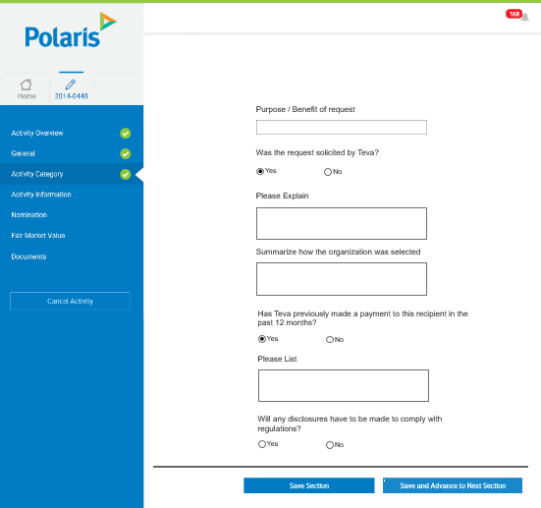

### Activity Category – Educational Sponsorships

#### Business Requirement Changes

|  |  |
| --- | --- |
| Original BR ID | Description |
| BR-ESC-001 | The request will follow the base advisory board workflow |
| BR-ESC-002 | The customizations should be added to the base advisory board request - activity category form |

#### Technical Customizations

##### Page Level Customizations

|  |  |  |  |  |
| --- | --- | --- | --- | --- |
| Attribute Type | Title | Description | Validation | Customization |
| Data Capture | Sponsorship Type | Add new field “Sponsorship Type” | * Field Format: Drop-down * Field position: Above Purpose * List Values: Promotional/Non-Promotional * Required: Yes * Validation: A non-blank drop down value must be selected | New |
| Data Capture | Purpose of request | Rename field “Purpose” to “Purpose of request” | * Field Format: Text box * Required: Yes * Validation: None * Field length: Keep default | Rename |
| Data Capture | Funding Decision Need by Date | Add New Field – Funding Decision Need by Date | * Field Format: Calendar * Field Position: Below Purpose of request * Required: Yes * Validation: Must be greater than created date and less than activity start date | New |
| Data Capture | Was the request solicited by Teva? | Add new field- Was the request solicited by Teva | * Field Format: Yes/No radio button * Required: Yes * Validation: Yes or no must be selected | New |
| Data Capture | Please Explain | Add new field- Please Explain | * Field Format: Free text box * Required: Yes, if Yes is selected for “Previous Field”, otherwise no * Validation: Field will be displayed only when “Yes” is selected for “Was the request solicited by Teva?” * Field length: 2000 characters | New |
| Data Capture | Has Teva provided an Educational Sponsorship to this recipient in the  past 12 months? | Add new field- Has Teva provided an Educational Sponsorship to this recipient in the  past 12 months? | * Field Format: Yes/No radio button * Required: Yes * Validation: Yes or no must be selected | New |
| Data Capture | Please List | Add New Field- Please List | * Field Format: Free text box * Required: Yes, if Yes is selected for “Previous Field”, otherwise no * Validation: Field will be displayed only when Yes is selected for “Has Teva provided an Educational Sponsorship to this recipient in the past 12 months?” * Field length: 2000 characters | New |
| Data Capture | Will any disclosures have to be made to comply with the regulations? | Add New Field- Will any disclosures have to be made to comply with the regulations? | * Field Format: Yes/No radio button * Required: Yes * Validation: Yes or no must be selected | New |
| Data Capture | Please Explain | Add new field- Please Explain | * Field Format: Free text box * Required: Yes, if Yes is selected for “Previous Field”, otherwise no * Validation: Field will be displayed only when “Yes” is selected for “Will any disclosures have to be made to comply with the regulations?” | New |

##### Technical Specification Changes

|  |  |  |  |
| --- | --- | --- | --- |
| BR ID | TR ID | Section Reference | Customization Description |
|  |  |  |  |

#### Wireframes

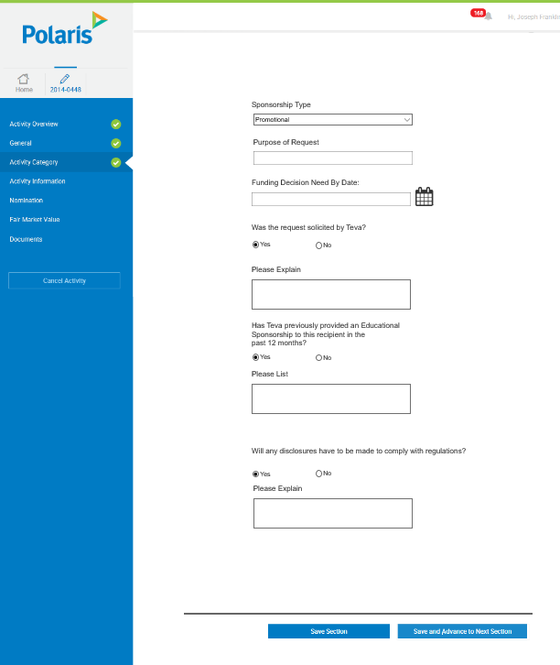

### Activity Category- Advisory Board/ Expert Meeting Activity

#### Business Requirements Changes

|  |  |
| --- | --- |
| Original BR ID | Description |
| BR-ADV-001 | The request will follow the base advisory board request workflow |
| BR-ADV-002 | The customizations should be added to the base Advisory board request - activity category form |

#### Technical Customizations

##### Page Level Customizations

|  |  |  |  |  |
| --- | --- | --- | --- | --- |
| Attribute Type | Title | Description | Validation | Customization |
| Data Capture | Are you attaching a completing and attaching an Advisory Board Form? | Add New Field - “Are you attaching a completing and attaching an Advisory Board Form?” | * Field Format: Yes/No Radio Button * Required: Yes * Validation: If Yes, the rest of the fields are NOT required. If No, all fields are required below. | New |
| Data Capture | Purpose | Add New Field- Purpose | * Field Format: Free Text Box * Required: Yes, if the answer to “Are you attaching a completing and attaching an Advisory Board Form?” = “No” * Validation: None * Field length: 2000 characters * Help text: Please describe the specific objectives you are trying to achieve with this Advisory Board | New |
| Data Capture | What needed services will the Advisors provide in the context of the meeting? | Add New Field- What needed services will the Advisors provide in the context of the meeting? | * Field Format: Free Text Box * Required: Yes, if the answer to “Are you attaching a completing and attaching an Advisory Board Form?” = “No” * Validation: There must be text in the box * Field length: 2000 characters | New |
| Data Capture | List specific advice to be obtained (answer to key questions) to support the objectives | Add New Field- Advice to be obtained List specific advice to be obtained (answer to key questions) to support the objectives | * Field Format: Free Text Box * Required: Yes, if the answer to “Are you attaching a completing and attaching an Advisory Board Form?” = “No” * Validation: None * Field length: 2000 characters * Help text: What questions need to be answered in order to satisfy the objectives of the Advisory Board? | New |
| Data Capture | Have meetings addressing the same subject or issue been held previously? | Add New Field- Have meetings addressing the same subject or issue been held previously? | * Field Format: Yes/No radio button * Required: Yes, if the answer to “Are you attaching a completing and attaching an Advisory Board Form?” = “No” * Validation: Yes or no must be selected | New |
| Data Capture | Please Explain | Add New Field- “Please Explain” | * Field Format: Free Text Box * Required: Yes, if Yes is selected for “Previous Field”, otherwise no * Validation: Text box will only be displayed when yes is selected for “Have meetings addressing the same subject or issue been held previously?” * Required: Yes, if “Have meetings addressing the same subject or issue been held previously?” is checked Yes * Field length: 2000 characters | New |
| Data Capture | Is any part of the information you are trying to obtain currently in the possession of Teva or obtained from published sources? | Add New Field - “Is any part of the information you are trying to obtain currently in the possession of Teva or obtained from published sources?” | * Field Format: Yes/No Radio Button * Required: Yes, if the answer to “Are you attaching a completing and attaching an Advisory Board Form?” = “No” * Validation: Yes or no must be selected | New |
| Data Capture | Please Explain | Add new field- Please Explain | * Field Format: Free text box * Required: Yes, if Yes is selected for “Previous Field”, otherwise no * Validation: Field will be displayed only when “Yes” is selected for “Is any part of the information you are trying to obtain currently in the possession of Teva or obtained from published sources?” * Field length: 2000 characters | New |
| Data Capture | Describe the criteria for selecting the advisors and how it relates to the purpose of the meeting | Add New Field- Describe the criteria for selecting the advisors and how it relates to the purpose of the meeting | * Field Format: Free Text Box * Required: Yes, if the answer to “Are you attaching a completing and attaching an Advisory Board Form?” = “No” * Validation: None * Field length: 2000 characters * Help text: What is the rationale for the Advisors you are choosing - how does their expertise support obtaining the information you need to reach you objectives? | New |
| Data Capture | How many Advisors are proposed to attend? | Add New Field- How many Advisors are proposed to attend | * Field Format: Numeric Textbox * Required: Yes, if the answer to “Are you attaching a completing and attaching an Advisory Board Form?” = “No” * Validation: A number must be input in the field * Field length: 20 characters * Help text: The business need must justify the number of Advisors expected to attend | New |
| Data Capture | How many Teva employees and describe their role/department/title? | Add New Field- How many Teva employees and describe their role/department/title? | * Field Format: Free Text Box * Required: Yes, if the answer to “Are you attaching a completing and attaching an Advisory Board Form?” = “No” * Validation: Text must be input in the field * Field length: 2000 characters * Help text: Teva employees must have a specific purpose to attend the Advisory Board | New |
| Data Capture | How did you determine the number of Advisors and Employees? | Add New Field- How did you determine this number | * Field Format: Free Text Box * Required: Yes, if the answer to “Are you attaching a completing and attaching an Advisory Board Form?” = “No” * Validation: Text must be present in the field * Field length: 2000 characters * Help text: Ensure that the number of attendees allows an opportunity to participate in the discussion by all attendees | New |
| Data Capture | Specific action to be taken with this advice. How will the information from the meeting be collected, documented, and used? | Add New Field- Specific action to be taken with this advice. How will the information from the meeting be collected, documented, and used | * Field Format: Free Text Box * Required: Yes, if the answer to “Are you attaching a completing and attaching an Advisory Board Form?” = “No” * Validation: Text must be present in the field * Field length: 2000 characters | New |
| Data Capture | Who will prepare a report of the meeting, recommendations, and evaluate the advice and within what time frame? | Add New Field- Who will prepare a report of the meeting, recommendations, and evaluate the advice and within what time frame? | * Field Format: Free Text Box * Required: Yes, if the answer to “Are you attaching a completing and attaching an Advisory Board Form?” = “No” * Validation: None * Field length: 2000 characters | New |

##### Technical Specification Changes

|  |  |  |  |
| --- | --- | --- | --- |
| BR ID | TR ID | Section Reference | Customization Description |
|  |  |  |  |

#### Wireframes

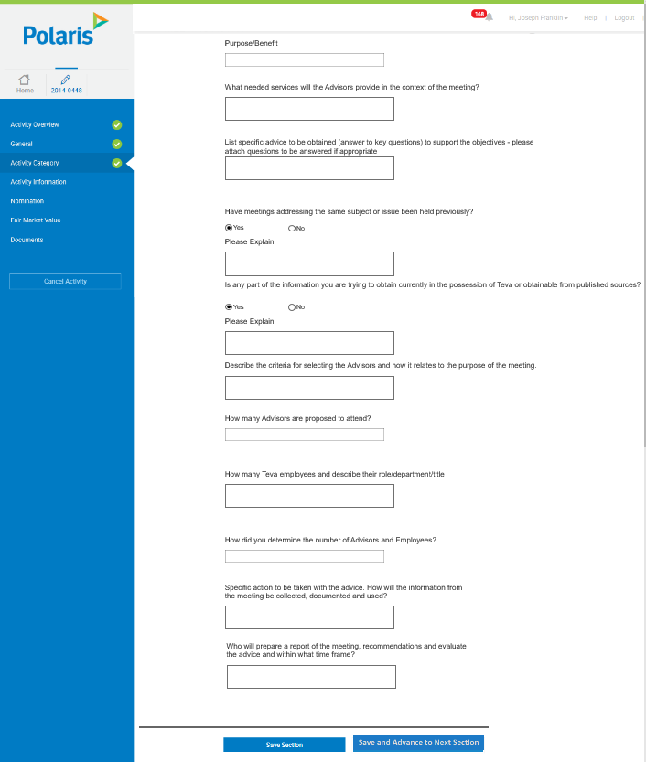

### Activity Category- Items/Gifts Activity

#### Business Requirements Changes

|  |  |
| --- | --- |
| Original BR ID | Description |
| BR-IGA-001 | The request will follow the base grants and donations workflow |
| BR-IGA-002 | The customizations should be added to the base grants and donations request - activity category form |

#### Technical Customizations

##### Page Level Customizations

|  |  |  |  |  |
| --- | --- | --- | --- | --- |
| Attribute Type | Title | Description | Validation | Customization |
| Data Capture | Business relationship between Requestor and Recipient | Add new field “Business relationship between Requestor and Recipient” | * Field Format: Text box * Required: Yes * Validation: Text must be present in this field * Field Length:2000 characters | New |
| Data Capture | Description of Gift | Add New Field- Description of Gift | * Field Format: Free Text Box * Character Limit: * Required: Yes * Validation: Text must be present in this field * Field length: 2000 characters | New |
| Data Capture | Does the gift have a Company or Product logo? | Add New Field- Does the gift have a Company or Product logo? | * Field Format: Yes/No radio button * Required: Yes * Validation: Yes or no must be selected | New |
| Data Capture | Purpose of Gift | Add New Field – Purpose of Gift | * Field Format: Free Textbox * Required: Yes * Validation: Text must be present in this field * Field length: 2000 characters | New |
| Data Capture | Gift(s) value | Add New Field- Gift(s) value | * Field Format: Numeric text box * Character Limit: * Required: Yes * Validation: A number must be present in this field * Field length: 20 characters | New |
| Data Capture | Currency | Add New Field- Currency | * Field Format: Drop down of supported currencies * Required: Yes * Validation: Aa non-blank option must be selected | New |

##### Technical Specification Changes

|  |  |  |  |
| --- | --- | --- | --- |
| BR ID | TR ID | Section Reference | Customization Description |
|  |  |  |  |

#### Wireframes

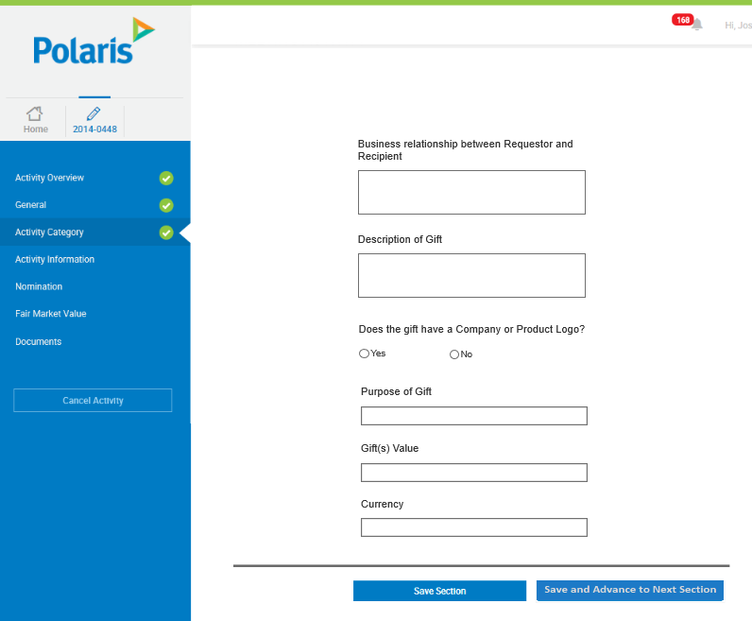

### Activity Category- Hospitality Activity

#### Business Requirements Changes

|  |  |
| --- | --- |
| Original BR ID | Description |
| BR-HOS-001 | The request will follow the base grants and donations workflow |
| BR-HOS-002 | The customizations should be added to the base grants and donations request - activity category form |

#### Technical Customizations

##### Page Level Customizations

|  |  |  |  |  |
| --- | --- | --- | --- | --- |
| Attribute Type | Title | Description | Validation | Customization |
| Data Capture | Estimated Number of Attendees | Add New Field- Estimated Number of Attendees | * Field Format: Numeric Text Box * Character Limit: * Required: Yes * Validation: Text must be present in this field * Field length: 5 characters | New |
| Data Capture | How many Teva Employees? | Add New Field – How many Teva Employees? | * Field Format: Numeric Text Box * Required: Yes * Validation: A number must be present in this field * Field length: 5 characters | New |
| Data Capture | Expected Meal Cost Per Attendee | Add New Field – Expected Meal Cost Per Attendee | * Field Format: Numeric Text Box * Required: Yes * Validation: A number must be present in this field * Field length: 6 | New |
| Data Capture | Will you use an agency/vendor to execute this activity? | Add New Field - “Will you use an agency/vendor to execute this activity?” | * Field Format: Yes/No Radio Button * Required: Yes * Validation: Same as base | New (Same format as in Activity Information in base) |
| Data Capture | Agency/Vendor Name | Add New Field – Agency/Vendor Name | * Field Format: Free Text Box * Required Yes * Validation: Field will only appear if “Yes” is answered to “Will you use an agency/vendor to execute this activity?” | New (Same format as in Activity Information in base) |
| Data Capture | Full Name of Agency/Vendor Contact | Add New Field – Full Name of Agency/Vendor Contact | * Field Format: Free Text Box * Required Yes * Validation: Field will only appear if “Yes” is answered to “Will you use an agency/vendor to execute this activity?” | New (Same format as in Activity Information in base) |
| Data Capture | Vendor Name / English (optional) | Add New Field – Vendor Name / English (optional) | * Field Format: Free Text box * Required: No * Position: After “Full Name of Agency/Vendor Contact” * Validation: Field will only appear if “Yes” is answered to “Will you use an agency/vendor to execute this activity?” | New (Same format as in Activity Information in base) |
| Data Capture | Disclaimer that Agency has been made aware of Teva Policies/Procedures | Add New Field - “Disclaimer that Agency has been made aware of Teva Policies/Procedures” | * Field Control: Checkbox * Required: Yes * Validation: Field will only appear if “Yes” is answered to “Will you use an agency/vendor to execute this activity?” | New (Same format as in Activity Information in base) |
| Data Capture | Has an approval been obtained from the Third Party Due Diligence Team? | Add New Field – Has an approval been obtained from the Third Party Due Diligence Team? | * Field Format: Yes/No Radio Button * Required: Yes * Validation: Field will only appear if “Yes” is answered to “Will you use an agency/vendor to execute this activity?” | New (Same format as in Activity Information in base) |
| Data Capture | Please State Why | Add New Field – Please State Why | * Field Format: Free Text Box * Required: Yes * Validation: Field will only appear if “No” is answered to “Has an approval been obtained from the Third Party Due Diligence Team?” | New (Same format as in Activity Information in base) |
| User Interface | Planned Meeting/Activity Location(s) Venue/Office Name & Address(es) | Display Meeting/Activity Location information | * **Field Control:** Read-Only Table * **Columns:** * 1. Venue Type (Read-Only Text) * 2. Venue Name (Read-Only Text) * 3. Address (Read-Only Text) * 4. Venue City (Read-Only Text) * 5. Venue Country (Read-Only Text) * Start Date (Read-Only Text) * End Date (Read-Only Text) * **Other Information:** If no record is in the table, displays the table header only. | New (Same format as in Activity Information in base) |
| Data Capture | Add Venue popup | Captures Venue Information | * Fields: Identified below * Add Venue (button, Add Venue to the table) | New (Same format as in Activity Information in base) |
| Data Capture – Add Venue | Venue Type | Add New Field – Venue Type | * Field Format: Dropdown * Required: Yes | New (Same format as in Activity Information in base) |
| Data Capture – Add Venue | Please State | Add New Field – Please State | * Field Format: Free Text Box * Required Yes * Validation: Will only appear if “Other” is selected for “Venue Type” | New (Same format as in Activity Information in base) |
| Data Capture | Venue Name | Add New Field – Venue Name | * Field Format: Free Text * Required: Yes * Validation: Same as base | New (Same format as in Activity Information in base) |
| Data Capture | Address | Add New Field – Address | * Field Format: Free Text * Required: No * Validation: Same as base | New (Same format as in Activity Information in base) |
| Data Capture | How was the location determined? | Add New Field- How was the location determined?  In the Add Venue pop-up | * Field Format: Free Text Box * Character Limit: * Required: Yes * Validation: Same as base | New (Same format as in Activity Information in base) |
| Data Capture | Venue Country | Add New Field - “Venue Country” | * Field Format: Dropdown * Required: Yes | New (Same format as in Activity Information in base) |
| Data Capture | Venue State | Add New Field - “Venue State” | * Field Format: Dropdown * Required: Yes * Validation: Field will only appear if “United States” is selected for “Venue Country” | New (Same format as in Activity Information in base) |
| Data Capture | Venue City | Add New Field – “Venue City” | * Field Format: Free Text Box * Required: Yes * Validation: Same as base | New (Same format as in Activity Information in base) |
| Data Capture | Venue Zip/Postal Code | Add New Field “Venue Zip/Postal Code” | * Field Format: Numeric Text Box * Required: No * Validation: Same as base | New (Same format as in Activity Information in base) |
| Data Capture | Meeting Dates | Add New Field – Meeting Dates  Same as base with first one as the “Start Date” and second one as “End Date” | * Field Format: Calendar * Required: Yes * Validation: The Start and End Dates must be between the Activity Start and End Dates. | New (Same format as in Activity Information in base) |

##### Technical Specification Changes

|  |  |  |  |
| --- | --- | --- | --- |
| BR ID | TR ID | Section Reference | Customization Description |
|  |  |  |  |

#### Wireframes

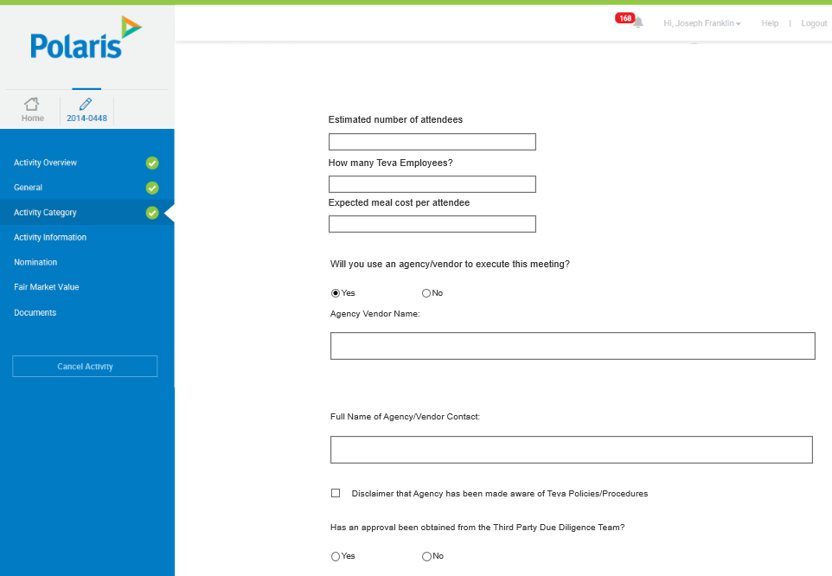

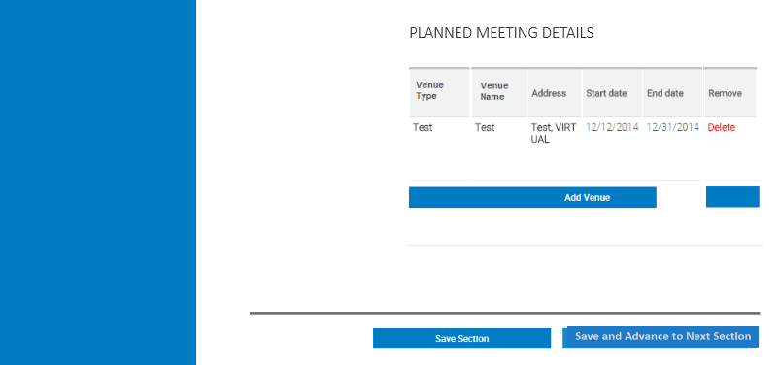

### Activity Category- Sponsorship of Third Party Event/ Activity

#### Business Requirements Changes

|  |  |
| --- | --- |
| Original BR ID | Description |
| BR-STP-001 | The request will follow the base advisory board workflow |
| BR-STP-002 | The customizations should be added to the base advisory board request - activity category form |

#### Technical Customizations

##### Page Level Customizations

|  |  |  |  |  |
| --- | --- | --- | --- | --- |
| Attribute Type | Title | Description | Validation | Customization |
| Data capture | Will Teva be mentioned as a sponsor of the event in the event materials, event publications, or other materials distributed during the event? | Add New Field- Will Teva be mentioned as a sponsor of the event in the event materials, event publications, or other materials distributed during the event? | * Field Format: Yes/No radio button * Required: Yes * Validation: Yes or no must be selected | New |
| Data capture | Will Teva be promoting products at the event? | Add New Field- Will Teva be promoting products at the event? | * Field Format: Yes/No radio button * Required: Yes * Validation: Yes or no must be selected | New |
| Data capture | Is this an Industry sponsored event? | Add New Field- Is this an Industry sponsored event? | * Field Format: Yes/ No radio button * Required: Yes * Validation: Yes or no must be selected | New |
| Data capture | How does the event relate to Teva’s products? | Add New Field- How does the event relate to Teva’s products? | * Field Format: Free Text Box * Character Limit: * Required: Yes * Validation: Text must be present in this field * Field length: 2000 characters | New |
| Data capture | Who suggested or asked that Teva support this event? | Add New Field- Who suggested or asked that Teva support this event? | * Field Format: Free Text Box * Character Limit: * Required: Yes * Validation: Text must be present in this field * Field length: 2000 characters | New |
| Data capture | What is the purpose of supporting this event? | Add New Field- What is the purpose of supporting this event? | * Field Format: Drop down box * Drop down Choices: Promotion of company’s products, Training on company products safe and effective use, Other * Required: Yes * Validation: A non-blank option must be selected from the dropdown | New |
| Data Capture | Please Explain | Add new field- “Please Explain” | * Field Format: Free text box * Required: Yes, if Yes is selected for “Previous Field”, otherwise no * Validation: Field will be displayed only when “Other” is selected for “What is the purpose of supporting this event?” * Field length: 2000 characters | New |
| Data capture | Number of expected participants | Add New Field – “Number of expected participants” | * Field Format: Numeric Text Box * Required: Yes * Validation: A number must be present in this field * Field length: 6 characters | New |
| Data capture | Name of any employees that will be present including their role/title | Add New Field – “Name of any employees that will be present including their role/title” | * Field Format: Free Text Box * Required: Yes * Validation: Text must be present in this field * Field length: 2000 characters | New |
| Data capture | Has a Teva employee been asked to speak at the event? | Add New Field – “Has a Teva employee been asked to speak at the event?” | * Field Format: Yes/No Radio Button * Required: Yes * Validation: Yes or no must be selected | New |

##### Technical Specification Changes

|  |  |  |  |
| --- | --- | --- | --- |
| BR ID | TR ID | Section Reference | Customization Description |
|  |  |  |  |

#### Wireframes

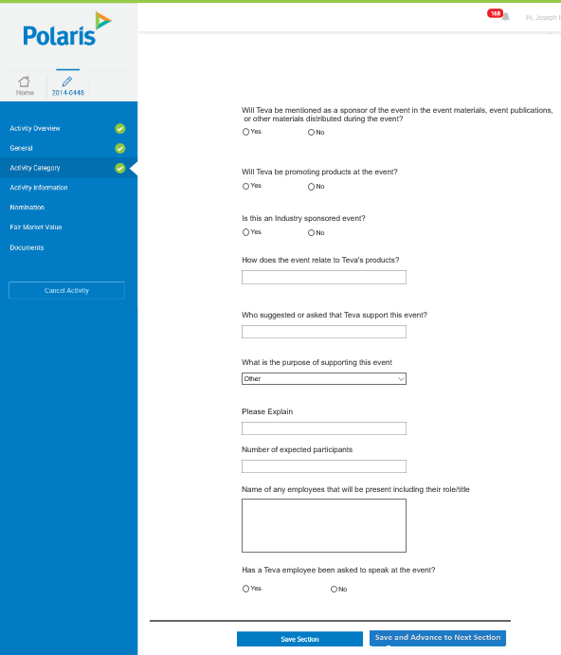

### Activity Category- Community Donation

#### Business Requirements Changes

|  |  |
| --- | --- |
| Original BR ID | Description |
| BR-COM-001 | The request will follow the base grants and donations workflow |
| BR-COM-002 | The customizations should be added to the base grants and donations request - activity category form |

#### Technical Customizations

##### Page Level Customizations

|  |  |  |  |  |
| --- | --- | --- | --- | --- |
| Attribute Type | Title | Description | Validation | Customization |
| Data Capture | Overview of the Organization | Add new field – “Overview of the Organization” | * Field Format: Free Text Box * Required: Yes * Validation: Text must be present in this field * Field length: 2000 characters | New |
| Data Capture | Has due diligence been conducted on the Recipient? | Add new field – “Has due diligence been conducted on the Recipient?” | * Field Format: Yes/No Radio Button * Required: Yes * Validation: Yes or no must be selected | New |
| Data Capture | Purpose of request | Add new field – “Purpose of request” | * Field Format: Free Text Box * Required: Yes * Validation: Text must be present in this field * Field length: 2000 characters | New |
| Data Capture | Was the request initiated by Teva? | Add new field – “Was the request initiated by Teva?” | * Field Format: Yes/No Radio Button * Required: Yes * Validation: None | New |
| Data Capture | Please Explain | Add new field- “Please Explain” | * Field Format: Free text box * Required: Yes, if Yes is selected for “Previous Field”, otherwise no * Validation: Field will be displayed only when “Yes” is selected for “Was the request initiated by Teva?” * Field length: 2000 characters | New |
| Data Capture | Summarize how the organization was selected | Add new field- Summarize how the organization was selected | * Field Format: Free text field * Required: Yes * Validation: Text must be present in this field * Field length: 2000 characters | New |
| Data Capture | Has Teva provided a Donation to this recipient in the  past 12 months? | Add new field- Has Teva provided a Donation to this recipient in the  past 12 months? | * Field Format: Yes/No radio button * Required: Yes * Validation: Yes or no must be selected | New |
| Data Capture | Please List | Add New Field- Please List | * Field Format: Free text box * Required: Yes, if Yes is selected for “Previous Field”, otherwise no * Validation: Field will be displayed only when Yes is selected for “Has Teva provided a Donation to this recipient in the past 12 months?” * Field length: 2000 characters | New |
| Data Capture | Will any disclosures have to be made to comply with the regulations | Add New Field- Will any disclosures have to be made to comply with the regulations | * Field Format: Yes/No radio button * Required: Yes * Validation: Yes or no must be selected | New |
| Data Capture | Please Explain | Add new field- “Please Explain” | * Field Format: Free text box * Required: Yes, if Yes is selected for “Previous Field”, otherwise no * Validation: Field will be displayed only when “Yes” is selected for “Will any disclosures have to be made to comply with the regulations?” * Field length: 2000 characters | New |
| Data Capture | If recipient is an organization, is the organization a bona fide charitable organization used only for charitable purposes? | Add new field – “If recipient is an organization, is the organization a bona fide charitable organization used only for charitable purposes?” | * Field Format: Yes/No radio button * Required: Yes * Validation: Yes or no must be selected | New |

##### Technical Specification Changes

|  |  |  |  |
| --- | --- | --- | --- |
| BR ID | TR ID | Section Reference | Customization Description |
|  |  |  |  |

#### Wireframes

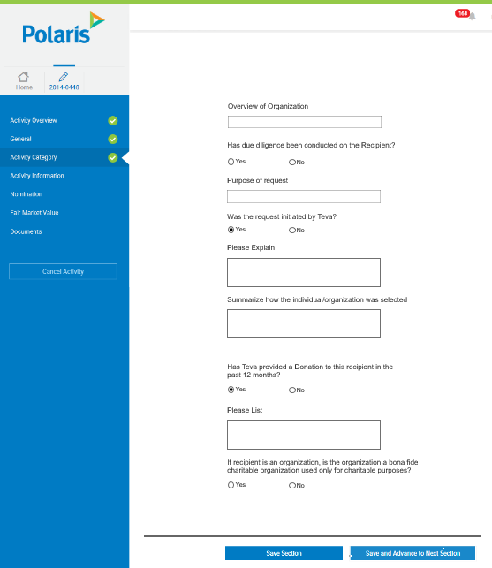

### Activity Category- Research Grants

#### Business Requirements Changes

|  |  |
| --- | --- |
| Original BR ID | Description |
| BR-RES-001 | The request will follow the base grants and donations workflow |
| BR-RES-002 | The customizations should be added to the base grants and donations request - activity category form |

#### Technical Customizations

##### Page Level Customizations

|  |  |  |  |  |
| --- | --- | --- | --- | --- |
| Attribute Type | Title | Description | Validation | Customization |
| Data Capture | Purpose of request | Add new field – “Purpose of request” | * Field Format: Free Text Box * Required: Yes * Validation: Text must be present in this field * Field length: 2000 characters | New |
| Data Capture | Was the request solicited by Teva? | Add new field – “Was the request solicited by Teva?” | * Field Format: Yes/No Radio Button * Required: Yes * Validation: Yes or no must be selected | New |
| Data Capture | Please Explain | Add new field- “Please Explain” | * Field Format: Free text box * Required: Yes, if Yes is selected for “Previous Field”, otherwise no * Validation: Field will be displayed only when “Yes” is selected for “Was the request solicited by Teva?” * Field length: 2000 characters | New |
| Data Capture | Summarize how the organization was selected | Add new field- Summarize how the organization was selected | * Field Format: Free text field * Required: Yes * Validation: Text must be present in this field * Field length: 2000 characters | New |
| Data Capture | Has Teva previously provided a Grant to this recipient in the past 12 months? | Add new field- Has Teva previously provided a Grant to this recipient in the past 12 months? | * Field Format: Yes/No radio button * Required: Yes * Validation: Yes or no must be selected | New |
| Data Capture | Please List | Add New Field- Please List | * Field Format: Free text box * Required: Yes, if Yes is selected for “Previous Field”, otherwise no * Validation: Field will be displayed only when Yes is selected for “Has Teva previously provided a Grant to this recipient in the past 12 months?” * Field length: 2000 characters | New |
| Data Capture | Will any disclosures have to be made to comply with the regulations | Add New Field- Will any disclosures have to be made to comply with the regulations | * Field Format: Yes/No radio button * Required: Yes * Validation: Yes or no must be selected | New |

##### Technical Specification Changes

|  |  |  |  |
| --- | --- | --- | --- |
| BR ID | TR ID | Section Reference | Customization Description |
|  |  |  |  |

#### Wireframes

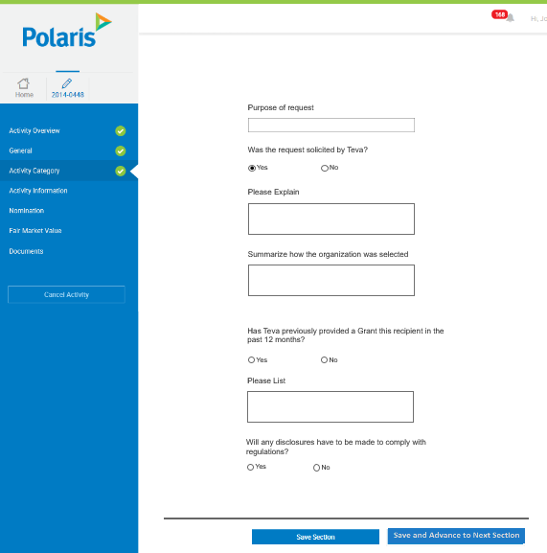

### Activity Category- Corporate Membership

#### Business Requirements Changes

|  |  |
| --- | --- |
| Original BR ID | Description |
| BR-COR-001 | The request will follow the base grants and donations workflow |
| BR-COR-002 | The customizations should be added to the base grants and donations request - activity category form |

#### Technical Customizations

##### Page Level Customizations

|  |  |  |  |  |
| --- | --- | --- | --- | --- |
| Attribute Type | Title | Description | Validation | Customization |
| Data Capture | Summary of the Organization | Add new field – “Summary of the Organization” | * Field Format: Free Text Box * Required: Yes * Validation: Text must be present * Field length: 2000 characters | New |
| Data Capture | Funding Decision Need by Date | Add new field – Funding Decision Need by Date | * Field Format: Calendar * Required: Yes * Validation: Selected date must be before activity start date | New |
| Data Capture | Summarize how the individual/organization was selected | Add new field- Summarize how the organization was selected | * Field Format: Free text field * Required: Yes * Validation: Text must be present * Field length: 2000 characters | New |
| Data Capture | Was the request solicited by Teva? | Add new field – “Was the request solicited by Teva?” | * Field Format: Yes/No Radio Button * Required: Yes * Validation: Yes or no must be selected | New |
| Data Capture | Please Explain | Add new field- “Please Explain” | * Field Format: Free text box * Required: Yes, if Yes is selected for “Previous Field”, otherwise no * Validation: Field will be displayed only when “Yes” is selected for “Was the request solicited by Teva?” * Field length: 2000 characters | New |
| Data Capture | Has Teva previously made a payment to this recipient in the past 12 months? | Add new field- Has Teva previously made a payment to this recipient in the past 12 months? | * Field Format: Yes/No radio button * Required: Yes * Validation: Yes or no must be selected | New |
| Data Capture | Please List | Add New Field- Please List | * Field Format: Free text box * Required: Yes, if Yes is selected for “Previous Field”, otherwise no * Validation: Field will be displayed only when Yes is selected for “Has Teva previously made a payment to this recipient in the past 12 months?” * Field length: 2000 characters | New |

##### Technical Specification Changes

|  |  |  |  |
| --- | --- | --- | --- |
| BR ID | TR ID | Section Reference | Customization Description |
|  |  |  |  |

#### Wireframes

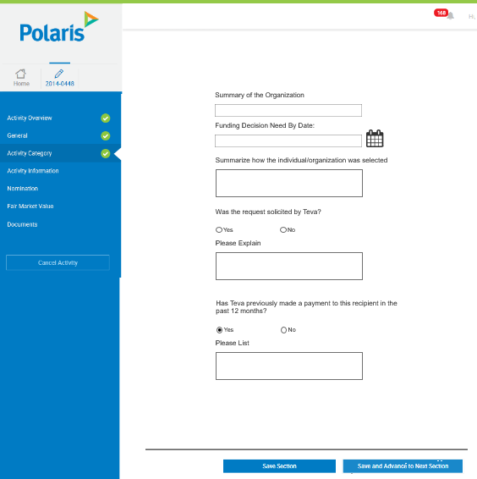

### Activity Category- Educational Grants/Scholarships

#### Business Requirements Changes

|  |  |
| --- | --- |
| Original BR ID | Description |
| BR-EGS-001 | The request will follow the base grants and donations workflow |
| BR-EGS-002 | The customizations should be added to the base grants and donations request - activity category form |

#### Technical Customizations

##### Page Level Customizations

|  |  |  |  |  |
| --- | --- | --- | --- | --- |
| Attribute Type | Title | Description | Validation | Customization |
| Data Capture | Purpose of request | Add new field – “Purpose of request” | * Field Format: Free Text Box * Required: Yes * Validation: Text must be present in the field * Field length: 2000 characters | New |
| Data Capture | Funding Decision Need by Date | Add new field – Funding Decision Need by Date | * Field Format: Calendar * Required: Yes * Validation: Date selected must be before activity start date | New |
| Data Capture | Summarize how the organization was selected | Add new field- Summarize how the organization was selected | * Field Format: Free text field * Required: Yes * Validation: Text must be present * Field length: 2000 characters | New |
| Data Capture | Was the request initiated by Teva? | Add new field – “Was the request initiated by Teva?” | * Field Format: Yes/No Radio Button * Required: Yes * Validation: Yes or no must be selected | New |
| Data Capture | Please Explain | Add new field- “Please Explain” | * Field Format: Free text box * Required: Yes, if Yes is selected for “Previous Field”, otherwise no * Validation: Field will be displayed only when “Yes” is selected for “Was the request initiated by Teva?” * Field length: 2000 characters | New |
| Data Capture | Has Teva provided an Educational Grant or Scholarship to this recipient in the past 12 months? | Add new field- Has Teva provided an Educational Grant or Scholarship to this recipient in the past 12 months? | * Field Format: Yes/No radio button * Required: Yes * Validation: Yes or no must be selected | New |
| Data Capture | Please List | Add New Field- Please List | * Field Format: Free text box * Required: Yes, if Yes is selected for “Previous Field”, otherwise no * Validation: Field will be displayed only when Yes is selected for “Has Teva provided an Educational Grant or Scholarship to this recipient in the past 12 months?” * Field length: 2000 characters | New |
| Data Capture | Will any disclosures have to be made to comply with the regulations | Add New Field- Will any disclosures have to be made to comply with the regulations | * Field Format: Yes/No radio button * Required: Yes * Validation: Yes or no must be selected | New |
| Data Capture | Please Explain | Add new field- “Please Explain” | * Field Format: Free text box * Required: Yes, if Yes is selected for “Previous Field”, otherwise no * Validation: Field will be displayed only when “Yes” is selected for “Will any disclosures have to be made to comply with regulations?” * Field length: 2000 characters | New |

##### Technical Specification Changes

|  |  |  |  |
| --- | --- | --- | --- |
| BR ID | TR ID | Section Reference | Customization Description |
|  |  |  |  |

#### Wireframes

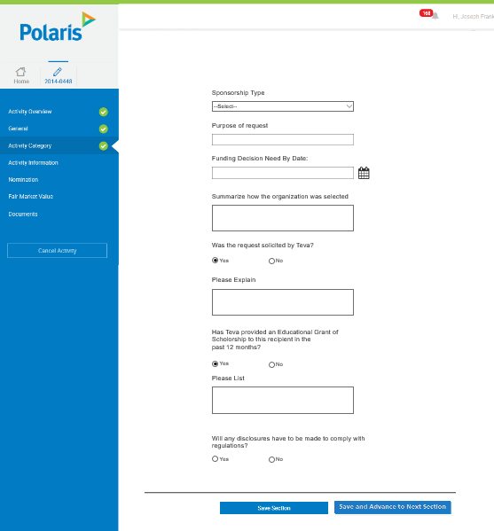

### Activity Category- Equipment/Product Donation

#### Business Requirements Changes

|  |  |
| --- | --- |
| Original BR ID | Description |
| BR-EQU-001 | The request will follow the base grants and donations workflow |
| BR-EQU-002 | The customizations should be added to the base grants and donations request - activity category form |

#### Technical Customizations

##### Page Level Customizations

|  |  |  |  |  |
| --- | --- | --- | --- | --- |
| Attribute Type | Title | Description | Validation | Customization |
| Data Capture | Support Type | Add New Field “Support Type” | * Field Format: Dropdown * List Values: Product Infrastructure/Equipment * Required: Yes * Validation: A non-blank dropdown value must be selected | New |
| Data Capture | Has due diligence been conducted on the Recipient? | Add new field – “Has due diligence been conducted on the Recipient?” | * Field Format: Yes/No Radio Button * Required: Yes * Validation: Yes or no must be selected | New |
| Data Capture | Purpose of request | Add new field – “Purpose of request” | * Field Format: Free Text Box * Required: Yes * Validation: Text must be present in the field * Field length: 2000 characters | New |
| Data Capture | Was the request initiated by Teva? | Add new field – “Was the request initiated by Teva?” | * Field Format: Yes/No Radio Button * Required: Yes * Validation: Yes or no must be selected | New |
| Data Capture | Please Explain | Add new field- “Please Explain” | * Field Format: Free text box * Required: Yes, if Yes is selected for “Previous Field”, otherwise no * Validation: Field will be displayed only when “Yes” is selected for “Was the request initiated by Teva?” * Field length: 2000 characters | New |
| Data Capture | Summarize how the organization was selected | Add new field- Summarize how the organization was selected | * Field Format: Free text field * Required: Yes * Validation: Text must be present in this field * Field length: 2000 characters | New |
| Data Capture | Has Teva provided a Donation to this recipient in the  past 12 months? | Add new field- Has Teva provided a Donation to this recipient in the  past 12 months? | * Field Format: Yes/No radio button * Required: Yes * Validation: Yes or no must be selected | New |
| Data Capture | Please List | Add New Field- Please List | * Field Format: Free text box * Required: Yes, if Yes is selected for “Previous Field”, otherwise no * Validation: Field will be displayed only when Yes is selected for “Has Teva provided a Donation to this to this recipient in the past 12 months?” * Field length: 2000 characters | New |
| Data Capture | Will any disclosures have to be made to comply with the regulations | Add New Field- Will any disclosures have to be made to comply with the regulations | * Field Format: Yes/No radio button * Required: Yes * Validation: Yes or no must be selected | New |
| Data Capture | Please Explain | Add new field- “Please Explain” | * Field Format: Free text box * Required: Yes, if Yes is selected for “Previous Field”, otherwise no * Validation: Field will be displayed only when “Yes” is selected for “Will any disclosures have to be made to comply with the regulations?” * Field length: 2000 characters | New |

##### Technical Specification Changes

|  |  |  |  |
| --- | --- | --- | --- |
| BR ID | TR ID | Section Reference | Customization Description |
|  |  |  |  |

#### Wireframes

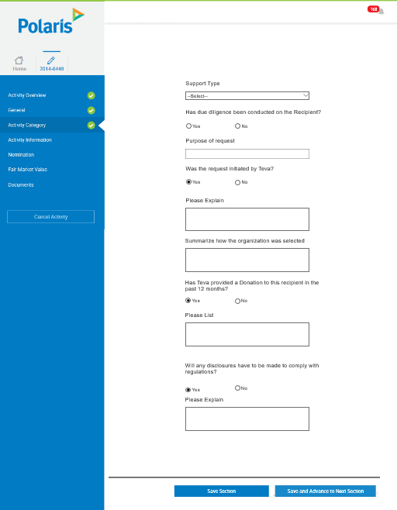

### Activity Category- Patient Support

#### Business Requirements Changes

|  |  |
| --- | --- |
| Original BR ID | Description |
| BR-PAT-001 | The request will follow the base grants and donations workflow |
| BR-PAT-002 | The customizations should be added to the base grants and donations request - activity category form |

#### Technical Customizations

##### Page Level Customizations

|  |  |  |  |  |
| --- | --- | --- | --- | --- |
| Attribute Type | Title | Description | Validation | Customization |
| Data Capture | Has due diligence been conducted on the Recipient? | Add new field – “Has due diligence been conducted on the Recipient?” | * Field Format: Yes/No Radio Button * Required: Yes * Validation: Yes or no must be selected | New |
| Data Capture | Purpose of request | Add new field – “Purpose of request” | * Field Format: Free Text Box * Required: Yes * Validation: Text must be present in the field * Field length: 2000 characters | New |
| Data Capture | Was the request initiated by Teva? | Add new field – “Was the request initiated by Teva?” | * Field Format: Yes/No Radio Button * Required: Yes * Validation: Yes or no must be selected | New |
| Data Capture | Please Explain | Add new field- “Please Explain” | * Field Format: Free text box * Required: Yes, if Yes is selected for “Previous Field”, otherwise no * Validation: Field will be displayed only when “Yes” is selected for “Was the request initiated by Teva?” * Field length: 2000 characters | New |
| Data Capture | Summarize how the organization was selected | Add new field- Summarize how the organization was selected | * Field Format: Free text field * Required: Yes * Validation: Text must be present in the field * Field length: 2000 characters | New |
| Data Capture | Has Teva provided support to this recipient in the  past 12 months? | Add new field- Has Teva provided support to this recipient in the  past 12 months? | * Field Format: Yes/No radio button * Required: Yes * Validation: Yes or no must be selected | New |
| Data Capture | Please List | Add New Field- Please List | * Field Format: Free text box * Required: Yes, if Yes is selected for “Previous Field”, otherwise no * Validation: Field will be displayed only when Yes is selected for “Has Teva provided support to this recipient in the past 12 months?” * Field length: 2000 characters | New |
| Data Capture | Will any disclosures have to be made to comply with the regulations | Add New Field- Will any disclosures have to be made to comply with the regulations | * Field Format: Yes/No radio button * Required: Yes * Validation: Yes or no must be selected | New |
| Data Capture | Please Explain | Add new field- “Please Explain” | * Field Format: Free text box * Required: Yes, if Yes is selected for “Previous Field”, otherwise no * Validation: Field will be displayed only when “Yes” is selected for “Will any disclosures have to be made to comply with the regulations?” * Field length: 2000 characters | New |
| Data Capture | Will you use an agency/vendor to execute this activity? | Add New Field - “Will you use an agency/vendor to execute this activity?” | * Field Format: Yes/No Radio Button * Required: Yes * Validation: Yes or no must be selected | New (Same format as in Activity Information in base) |
| Data Capture | Agency/Vendor Name | Add New Field – Agency/Vendor Name | * Field Format: Free Text Box * Required Yes * Validation: Field will only appear if “Yes” is answered to “Will you use an agency/vendor to execute this activity?” | New (Same format as in Activity Information in base) |
| Data Capture | Full Name of Agency/Vendor Contact | Add New Field – Full Name of Agency/Vendor Contact | * Field Format: Free Text Box * Required Yes * Validation: Field will only appear if “Yes” is answered to “Will you use an agency/vendor to execute this activity?” | New (Same format as in Activity Information in base) |
| Data Capture | Vendor Name / English (optional) | Add New Field – Vendor Name / English | * Field Format: Free Text box * Required: No * Position: After “Full Name of Agency/Vendor Contact” * Validation: Field will only appear if “Yes” is answered to “Will you use an agency/vendor to execute this activity?” | New (Same format as in Activity Information in base) |
| Data Capture | Disclaimer that Agency has been made aware of Teva Policies/Procedures | Add New Field - “Disclaimer that Agency has been made aware of Teva Policies/Procedures” | * Field Control: Checkbox * Required: Yes * Validation: Field will only appear if “Yes” is answered to “Will you use an agency/vendor to execute this activity?” | New (Same format as in Activity Information in base) |
| Data Capture | Has an approval been obtained from the Third Party Due Diligence Team? | Add New Field – Has an approval been obtained from the Third Party Due Diligence Team? | * Field Format: Yes/No Radio Button * Required: Yes * Validation: Field will only appear if “Yes” is answered to “Will you use an agency/vendor to execute this activity?” | New (Same format as in Activity Information in base) |
| Data Capture | Please State Why | Add New Field – Please State Why | * Field Format: Free Text Box * Required: Yes * Validation: Field will only appear if “No” is answered to “Has an approval been obtained from the Third Party Due Diligence Team?” | New (Same format as in Activity Information in base) |
| User Interface | Planned Meeting/Activity Location(s) Venue/Office Name & Address(es) | Display Meeting/Activity Location information | * **Field Control:** Read-Only Table * **Columns:** * 1. Venue Type (Read-Only Text) * 2. Venue Name (Read-Only Text) * 3. Address (Read-Only Text) * 4. Venue City (Read-Only Text) * 5. Venue Country (Read-Only Text) * Start Date (Read-Only Text) * End Date (Read-Only Text) * **Other Information:** If no record is in the table, displays the table header only. | New (Same format as in Activity Information in base) |
| Data Capture | Add Venue popup | Captures Venue Information | * Fields: Identified below * Add Venue (button, Add Venue to the table) | New (Same format as in Activity Information in base) |
| Data Capture – Add Venue | Venue Type | Add New Field – Venue Type | * Field Format: Dropdown * Required: Yes * Validation: A non-blank value from the dropdown must be selected | New (Same format as in Activity Information in base) |
| Data Capture – Add Venue | Please State | Add New Field – Please State | * Field Format: Free Text Box * Required Yes * Validation: Will only appear if “Other” is selected for “Venue Type” | New (Same format as in Activity Information in base) |
| Data Capture | Venue Name | Add New Field – Venue Name | * Field Format: Free Text * Required: Yes * Validation: Same as base | New (Same format as in Activity Information in base) |
| Data Capture | Address | Add New Field – Address | * Field Format: Free Text * Required: No * Validation: Same as base | New (Same format as in Activity Information in base) |
| Data Capture | How was the location determined? | Add New Field- How was the location determined?  In the Add Venue pop-up | * Field Format: Free Text Box * Character Limit: * Required: Yes * Validation: Same as base | New (Same format as in Activity Information in base) |
| Data Capture | Venue Country | Add New Field - “Venue Country” | * Field Format: Dropdown * Required: Yes * Validation: Same as default | New (Same format as in Activity Information in base) |
| Data Capture | Venue State | Add New Field - “Venue State” | * Field Format: Dropdown * Required: Yes * Validation: Field will only appear if “United States” is selected for “Venue Country” | New (Same format as in Activity Information in base) |
| Data Capture | Venue City | Add New Field – “Venue City” | * Field Format: Free Text Box * Required: Yes * Validation: Same as base | New (Same format as in Activity Information in base) |
| Data Capture | Venue Zip/Postal Code | Add New Field “Venue Zip/Postal Code” | * Field Format: Numeric Text Box * Required: No * Validation: Same as base | New (Same format as in Activity Information in base) |
| Data Capture | Meeting Dates | Add New Field – Meeting Dates  Same as base with first one as the “Start Date” and second one as “End Date” | * Field Format: Calendar * Required: Yes * Validation: The Start and End Dates must be between the Activity Start and End Dates. | New (Same format as in Activity Information in base) |

##### Technical Specification Changes

|  |  |  |  |
| --- | --- | --- | --- |
| BR ID | TR ID | Section Reference | Customization Description |
|  |  |  |  |

#### Wireframes

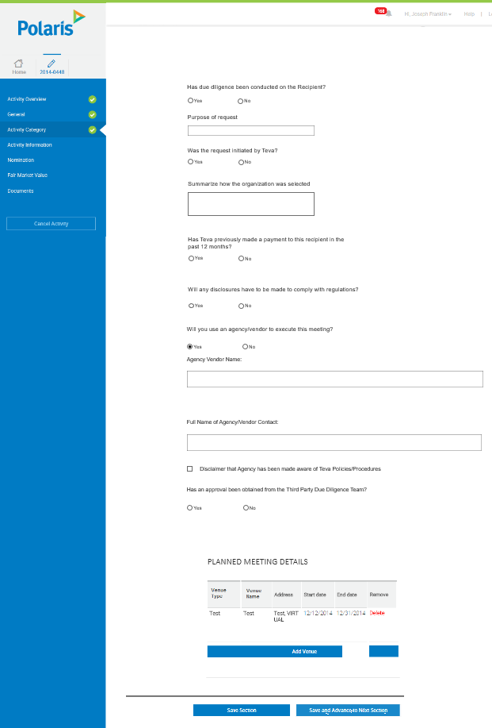

### Activity Category- Speaker Programs

#### Business Requirements Changes

|  |  |
| --- | --- |
| Original BR ID | Description |
| BR-PRO-001 | The request will follow the base advisory board workflow |
| BR-PRO-002 | The customizations should be added to the base advisory board request - activity category form |

#### Technical Customizations

##### Page Level Customizations

|  |  |  |  |  |
| --- | --- | --- | --- | --- |
| Attribute Type | Title | Description | Validation | Customization |
| Data Capture | Estimated number of Attendees | Add New Field - Estimated number of Attendees | * Field Format: Numeric Text Box * Required: Yes * Validation: A number must be present in this field * Field length: 5 characters | New |
| Data Capture | Expected Meal Cost Per Attendee | Add New Field – Expected Meal Cost Per Attendee | * Field Format: Numeric Text Box * Required: Yes * Validation: A number must be present in this field * Field length: 5 characters | New |
| Data Capture | Have relevant materials been reviewed and approved in appropriate system? | Add New Field - Have relevant materials been reviewed and approved in appropriate system? | * Field Format: Yes/No Radio Button * Required: Yes * Validation: Yes or no must be selected | New |
| Data Capture | Please Explain | Add new field- “Please Explain” | * Field Format: Free text box * Required: Yes, if Yes is selected for “Previous Field”, otherwise no * Validation: Field will be displayed only when “No” is selected for “Have relevant materials been reviewed and approved in appropriate system?” * Field length: 2000 characters | New |
| Data Capture | How were the attendees selected? | Add New Field - How were the attendees selected? | * Field Format: Free Text Box * Required: Yes * Validation: Text must be present in this field * Field length: 2000 characters | New |
| Data Capture | How were the speakers selected and by whom? | Add New Field - How were the speakers selected and by whom? | * Field Format: Free Text Box * Required: Yes * Validation: Text must be present in this field * Field length: 2000 characters | New |
| Data Capture | List the Teva employees anticipated to attend with their title, department and role | Add New Field - List the Teva employees anticipated to attend with their title, department and role | * Field Format: Free Text Box * Required: Yes * Validation: Text must be present in this field * Field length: 2000 characters | New |

##### Technical Specification Changes

|  |  |  |  |
| --- | --- | --- | --- |
| BR ID | TR ID | Section Reference | Customization Description |
|  |  |  |  |

#### Wireframes

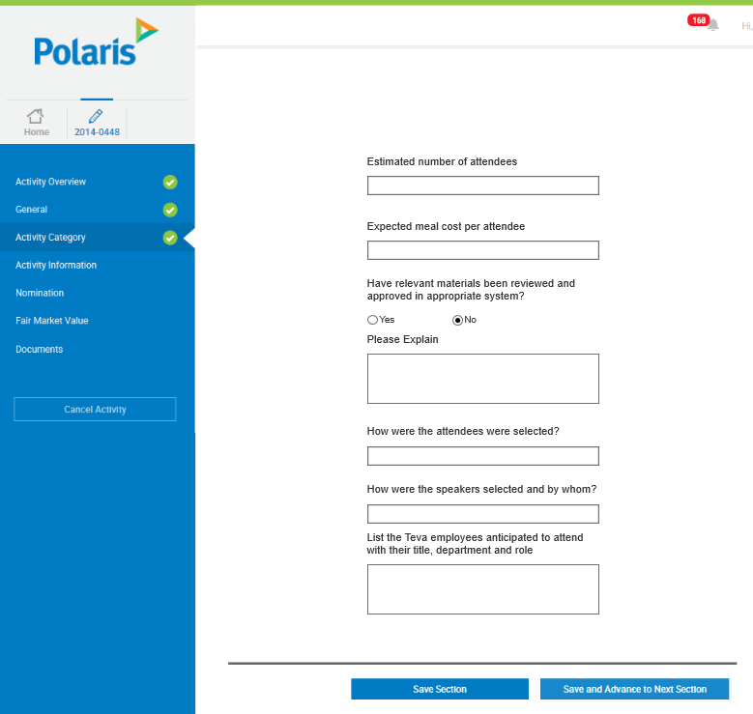

### Activity Category- Site Visit

#### Business Requirements Changes

|  |  |
| --- | --- |
| Original BR ID | Description |
| BR-VIS-001 | The request will follow the base advisory board workflow |
| BR-VIS-002 | The customizations should be added to the base advisory board request - activity category form |

#### Technical Customizations

##### Page Level Customizations

|  |  |  |  |  |
| --- | --- | --- | --- | --- |
| Attribute Type | Title | Description | Validation | Customization |
| Data Capture | Estimated number of Attendees | Add New Field - Estimated number of Attendees | * Field Format: Numeric Text Box * Required: Yes * Validation: A number must be present in the field * Field length: 5 | New |
| Data Capture | Expected Meal Cost Per Attendee | Add New Field – Expected Meal Cost Per Attendee | * Field Format: Numeric Text Box * Required: Yes * Validation: A number must be present in the field * Field length: 5 | New |
| Data Capture | Have relevant materials been reviewed and approved in appropriate system? | Add New Field - Have relevant materials been reviewed and approved in appropriate system? | * Field Format: Yes/No Radio Button * Required: Yes * Validation: Yes or no must be selected | New |
| Data Capture | Please Explain | Add new field- “Please Explain” | * Field Format: Free text box * Required: Yes, if Yes is selected for “Previous Field”, otherwise no * Validation: Field will be displayed only when “No” is selected for “Have relevant materials been reviewed and approved in appropriate system?” * Field length: 2000 characters | New |
| Data Capture | How were the attendees selected? | Add New Field - How were the attendees selected? | * Field Format: Free Text Box * Required: Yes * Validation: Text must be present in field * Field length: 2000 characters | New |
| Data Capture | List the Teva employees anticipated to attend with their title, department and role | Add New Field - List the Teva employees anticipated to attend with their title, department and role | * Field Format: Free Text Box * Required: Yes * Validation: Text must be present in the field * Field length: 2000 characters | New |

##### Technical Specification Changes

|  |  |  |  |
| --- | --- | --- | --- |
| BR ID | TR ID | Section Reference | Customization Description |
|  |  |  |  |

#### Wireframes

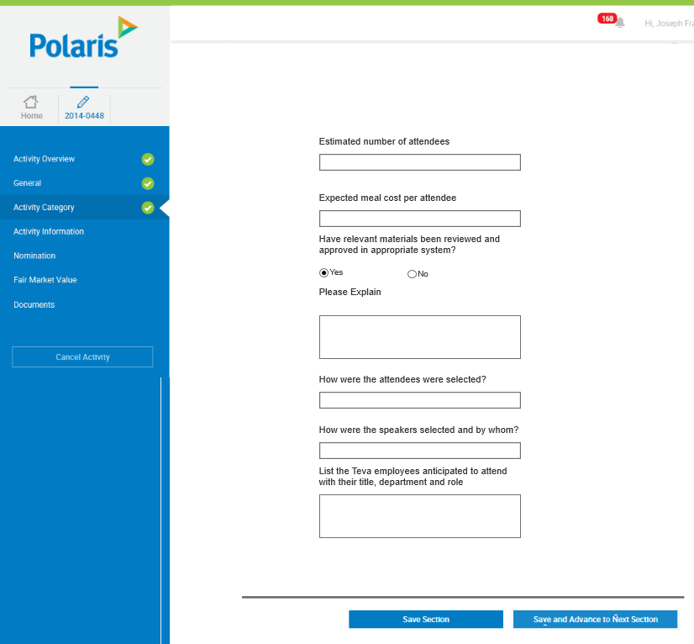

### Activity Category- Market Research

#### Business Requirements Changes

|  |  |
| --- | --- |
| Original BR ID | Description |
| BR-MAR-001 | The request will follow the base consulting workflow |
| BR-MAR-002 | The customizations should be added to the base consulting request - activity category form |

#### Technical Customizations

##### Page Level Customizations

|  |  |  |  |  |
| --- | --- | --- | --- | --- |
| Attribute Type | Title | Description | Validation | Customization |
| Data Capture | Will the name of the product be identified as part of the research? | Add New Field - Will the name of the product be identified as part of the research? | * Field Format: Yes/No Radio Button * Required: Yes * Validation: Yes or no must be selected | New |
| Data Capture | Please Explain | Add new field- “Please Explain” | * Field Format: Free text box * Required: Yes, if Yes is selected for “Previous Field”, otherwise no * Validation: Field will be displayed only when “Yes” is selected for “Will the name of the product be identified as part of the research?” * Field length: 2000 characters | New |
| Data Capture | Development Stage of product(s) | Add New Field - Development Stage of product(s) | * Field Format: Free Text Box * Required: Yes * Validation: Text must be present in the field * Field length: 2000 characters | New |
| Data Capture | Cross Border? | Add New Field - Cross Border? | * Field Format: Yes/No Radio Button * Required: Yes * Validation: Yes or no must be selected | New |
| Data Capture | Choose Countries Involved | Add New Field - Choose Countries Involved | * Field Format: Dropdown/Multiselect * Required: Yes * Validation: None | New |
| Data Capture | Phases of the Project | Add New Field - Phases of the Project | * Field Format: Free Text Box * Required: Yes * Validation: Text must be present in this field * Field length: 2000 characters | New |
| Data Capture | Proposed Data Collection Method (per phases) | Add New Field - Proposed Data Collection Method (per phases) | * Field Format: Free Text Box * Required: Yes * Validation: Text must be present in this field * Field length: 2000 characters | New |
| Data Capture | Description of all respondent groups/specialties to be included (please also state if patients/consumers are to be included) per phase/country | Add New Field - Description of all respondent groups/specialties to be included (please also state if patients/consumers are to be included) per phase/country | * Field Format: Free Text Box * Required: Yes * Validation: Text must be present in this field * Field length: 2000 characters | New |
| Data Capture | Total number of Health Care Professional (HCP) respondents to be included per phase/country | Add New Field - Total number of Health Care Professional (HCP) respondents to be included per phase/country | * Field Format: Numeric Text Box * Required: Yes * Validation: A number must be present in this field * Field length: 5 characters | New |
| Data Capture | Total number of Patients/Consumers to be included, pay rate and method of payment per phase/country | Add New Field - Total number of Patients/Consumers to be included, pay rate and method of payment per phase/country | * Field Format: Numeric Text Box * Required: Yes * Validation: A number must be present in this field * Field length: 5 characters | New |
| Data Capture | Total number of Payer respondents to be included per phase | Add New Field - Total number of Payer respondents to be included per phase | * Field Format: Numeric Text Box * Required: Yes * Validation: A number must be present in this field * Field length: 5 characters: | New |
| Data Capture | Proposed honoraria by respondent type, currency and way of payment per phase/country | Add New Field - Proposed honoraria by respondent type, currency and way of payment per phase/country | * Field Format: Free Text Box * Required: Yes * Validation: Text must be present in this field * Field length: 2000 characters | New |
| Data Capture | Approximate length of time required of respondent | Add New Field - Approximate length of time required of respondent | * Field Format: Alphanumeric Text Box * Required: Yes * Validation: Text/a number must be present in this field * Field length: 20 characters | New |
| Data Capture | Who will be making the payment to the respondent - Agency or local sub-contractors? | Add New Field - Who will be making the payment to the respondent - Agency or local sub-contractors? | * Field Format: Free Text Box * Required: Yes * Validation: Text must be present in this field * Field length: 2000 characters | New |
| Data Capture | Will Teva be revealed as the sponsoring company as part of the research? | Add New Field - Will Teva be revealed as the sponsoring company as part of the research? | * Field Format: Yes/No Radio Button * Required: Yes * Validation: Yes or no must be selected | New |
| Data Capture | Please Explain | Add new field- “Please Explain” | * Field Format: Free text box * Required: Yes, if Yes is selected for “Previous Field”, otherwise no * Validation: Field will be displayed only when “Yes” is selected for “Will Teva be revealed as the sponsoring company as part of the research?” * Field length: 2000 characters | New |
| Data Capture | Who will be selecting respondents? | Add New Field - Who will be selecting respondents? | * Field Format: Free Text Box * Required: Yes * Validation: Text must be present in this field * Field length: 2000 characters | New |
| Data Capture | Selection criteria for respondents | Add New Field - Selection criteria for respondents | * Field Format: Free Text Box * Required: Yes * Validation: Text must be present in this field * Field length: 2000 characters | New |
| Data Capture | Will Teva be blinded to the respondents’ identities? | Add New Field - Will Teva be blinded to the respondents’ identities? | * Field Format: Yes/No Radio Button * Required: Yes * Validation: Yes or no must be selected | New |
| Data Capture | Please Explain | Add new field- “Please Explain” | * Field Format: Free text box * Required: Yes, if Yes is selected for “Previous Field”, otherwise no * Validation: Field will be displayed only when “No” is selected for “Will Teva be blinded to the respondents’ identities?” * Field length: 2000 characters | New |
| Data Capture | Will a third-party vendor be used to organize this activity? | Add New Field - Will a third-party vendor be used to organize this activity? | * Field Format: Yes/No Radio Button * Required: Yes * Validation: Yes or no must be selected | New |
| Data Capture | Please provide vendor name | Add new field- “Please provide vendor name” | * Field Format: Free text box * Required: Yes * Validation: Field will be displayed only when “Yes” is selected for “Will a third-party vendor be used to organize this activity?” * Field length: 2000 characters | New |
| Data Capture | Has an approval been obtained from the Third Party Due Diligence Team? | Add New Field - Has an approval been obtained from the Third Party Due Diligence Team? | * Field Format: Radio Button * Values: Yes/No/ N/A * Required: Yes * Validation: Field will be displayed only when “Yes” is selected for “Will a third-party vendor be used to organize this activity?” * Field length: 2000 characters | New |
| Data Capture | Who will manage the contractual relationship with the Candidate? Include name, title, phone and country | Add New Field - Who will manage the contractual relationship with the Candidate? Include name, title, phone and country | * Field Format: Free Text Box * Required: Yes * Validation: Text must be present in this field * Field length: 2000 characters | New |

##### Technical Specification Changes

|  |  |  |  |
| --- | --- | --- | --- |
| BR ID | TR ID | Section Reference | Customization Description |
|  |  |  |  |

#### Wireframes

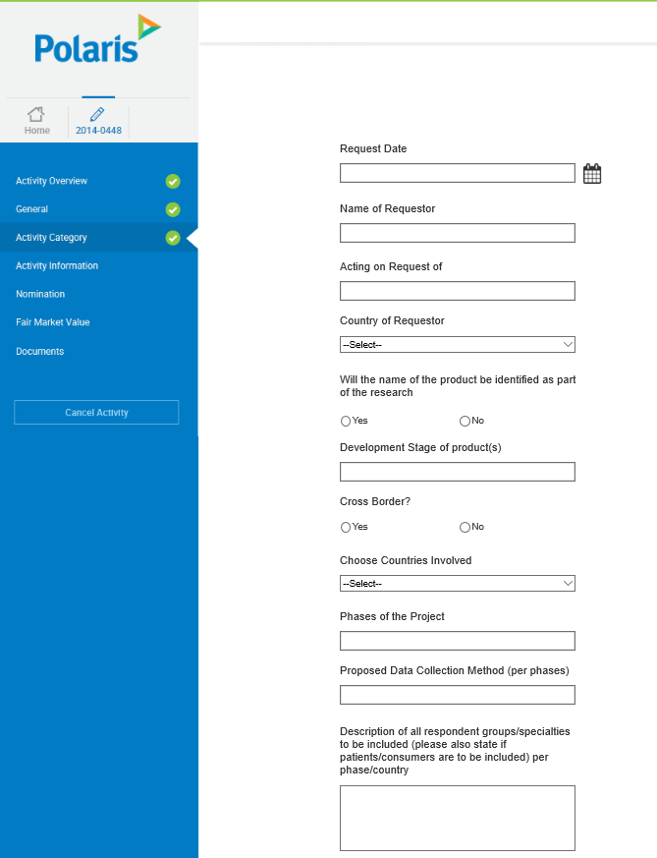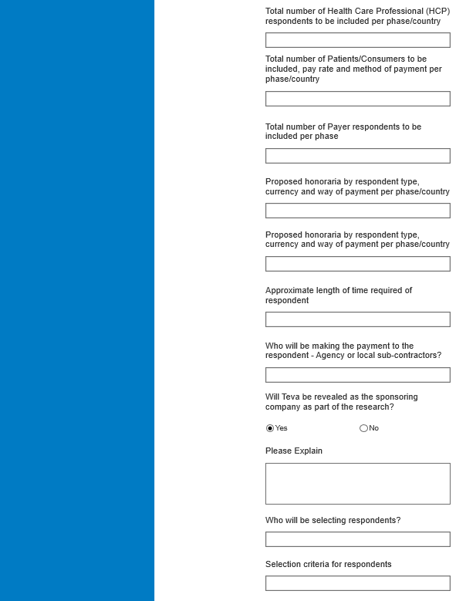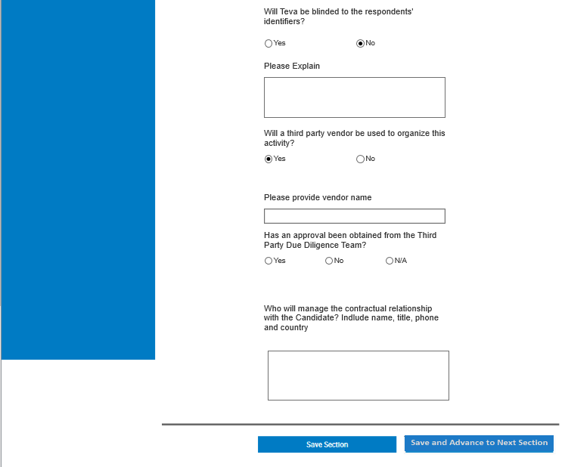

### Grants and Donations

#### Business Requirements Changes

|  |  |
| --- | --- |
| Original BR ID | Description |
| BR-GD-001 | Section will be renamed to “Activity Category” as it will be used for non-grant activities and Teva does not want to confused the users |

#### Technical Customizations

##### Page Level Customizations

|  |  |  |  |  |
| --- | --- | --- | --- | --- |
| Attribute Type | Title | Description | Validation | Customization |
|  |  |  |  |  |

##### Technical Specification Changes

|  |  |  |  |
| --- | --- | --- | --- |
| BR ID | TR ID | Section Reference | Customization Description |
|  |  |  |  |

#### Wireframes

### Activity Category – MSA (HIDDEN)

#### Business Requirements Changes

|  |  |
| --- | --- |
| Original BR ID | Description |
| BR-MSA-001 | MSA Activity Category to be hidden |
| BR-MSA-002 | Remove all mentions of MSA within Admin module, left hand panel and HCP profile. |

### Activity Information

#### Business Requirements Changes

|  |  |
| --- | --- |
| Original BR ID | Description |
| BR-ACI-001 | Remove Employee search functionality |
| BR-ACI-002 | User should be only allowed to add employees. |

#### Technical Customizations

##### Page Level Customizations

|  |  |  |  |  |
| --- | --- | --- | --- | --- |
| Attribute Type | Title | Description | Validation | Customization |
| Data Capture | Will you use an agency/vendor to execute this activity? | Rename “Will you use an agency/vendor to execute this meeting?” to “Will you use an agency/vendor to execute this activity?” | * Field Format: Yes/No Radio Button * Required: Yes * Validation: Yes or no button must be selected | Rename |
| Data Capture | Vendor Name / English (optional) | Add New Field – Vendor Name / English (optional) | * Field Format: Free Text box * Required: No * Position: After “Full Name of Agency/Vendor Contact” * Validation: Field will only appear if “Yes” is answered to “Will you use an agency/vendor to execute this activity?” * Field length: 2000 characters | New |
| Data Capture | Agency/Vendor Contact Email | Remove field | * Field Format: Free Text Box | Remove |
| Data Capture | Agency/Vendor Phone Number | Remove field | * Field Format: Free Text Box | Remove |
| Data Capture | Disclaimer that Agency has been made aware of Teva Policies/Procedures | Rename “I hereby certify that the Vendor has been trained on the appropriate Polaris policies and procedures required to conduct engagements with the Service Provider (s)” to “Disclaimer that Agency has been made aware of Teva Policies/Procedures” | * Field Control: Checkbox * Required: Yes * Validation: Field will only appear if “Yes” is answered to “Will you use an agency/vendor to execute this activity?” | Rename |
| Data Capture | Has an approval been obtained from the Third Party Due Diligence Team? | Add New Field – Has an approval been obtained from the Third Party Due Diligence Team? | * Field Format: Yes/No Radio Button * Required: Yes * Validation: Field will only appear if “Yes” is answered to “Will you use an agency/vendor to execute this activity?” | New |
| Data Capture | Please State Why | Add New Field – Please State Why | * Field Format: Free Text Box * Required: Yes, if Yes is selected for “Previous Field”, otherwise no * Validation: Field will only appear if “No” is answered to “Has an approval been obtained from the Third Party Due Diligence Team?” * Field length: 2000 characters | New |
| Data Capture | Please State | Add New Field - Please State  In the Add Venue Pop-up | * Field Format: Free Text Box * Required: Yes * Validation: Field will only appear if “Other” is selected for “Venue Type” * Field length: 2000 characters | New |
| Data Capture | How was the location determined? | Add New Field- How was the location determined?  In the Add Venue pop-up | * Field Format: Free Text Box * Location: Above Venue Country * Character Limit: * Required: Yes * Validation: Text must be present in this field * Field length: 2000 characters | New |
| Data Capture | Venue Country | Rename “Meeting Country” to “Venue Country” | * Field Format: Dropdown * Required: Yes * Validation: A non-blank value must be selected from the list | Rename |
| Data Capture | Venue State | Rename “Meeting State” to “Venue State” | * Field Format: Dropdown * Required: Yes * Validation: Field will only appear if “United States” is selected for “Venue Country” | Rename |
| Data Capture | Venue Zip/Postal Code | Rename “Meeting Zip/Postal Code” to “Venue Zip/Postal Code” | * Field Format: Numeric Text Box * Required: Yes * Validation: | Rename |
| Action | Search Employee | Remove employee search functionality  i.e Employee name and Search button | * Field Format: Text box * Action Type: Button | Remove |
| Page Element | Search for an HCP/ Add Employee | Rename the title in the Service provider & Attendee sub-tab to “Search for an HCP/Add Employee | * Field Type: Header | Rename |
| Data Capture Employee Table | Employee(s) | Allows the user to view and add employees to the activity | * Field Control: Table * Columns: “Name”, “Role”, “Department” * Only visible if the user selects the “Employee” radio button | New |
| Column in Employee Table | Name | Entire name of the employee being added | * Field control: Text Box * Field Format: Free Text | New |
| Column in Employee Table | Role | Role of the employee being added | * Field control: Text Box * Field Format: Free Text | New |
| Column in Employee Table | Department | Department of the employee being added | * Field control: Text box * Field Format: Free Text | New |
| Column in Employee Table | Delete | Allows the user to delete a row in the Employee Table | * Field control: Text link * Color: “Red” * If the user clicks this delete link the system will delete the entire row associated | New |
| Button | Add New Employee | Allows the user to create another row in the Employee Table | * Field Control: Button * This button will allow the user to add a new row to the employee table | New |

##### Technical Specification Changes

|  |  |  |  |
| --- | --- | --- | --- |
| BR ID | TR ID | Section Reference | Customization Description |
|  |  |  |  |

#### Wireframes

Activity Information:

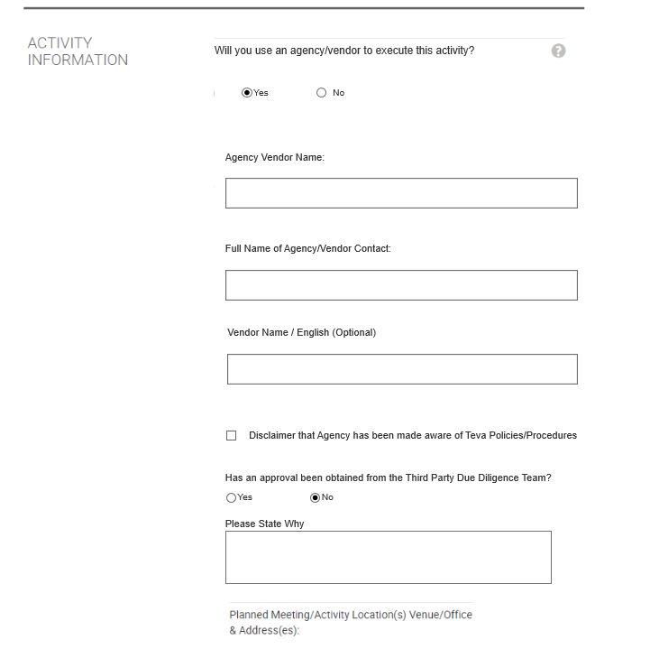

Add venue pop out:

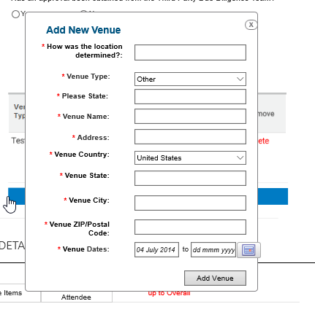

Add New Employee Table:

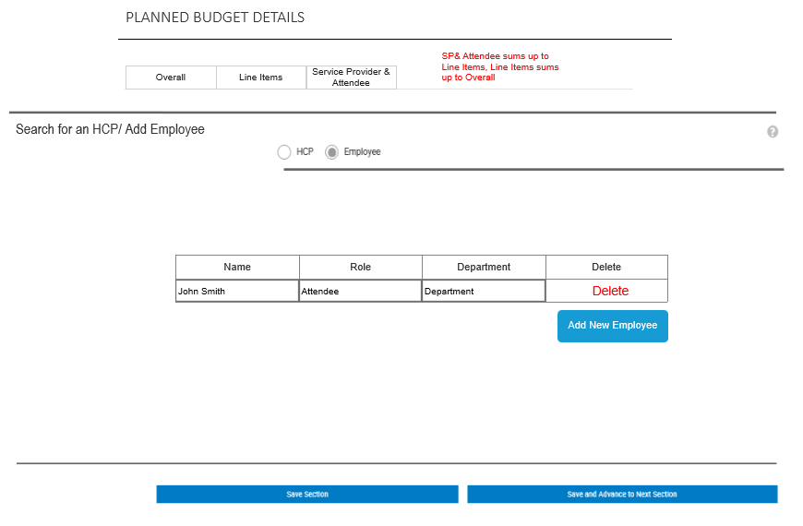

### Nominations

#### Business Requirements Changes

|  |  |
| --- | --- |
| Original BR ID | Description |
|  |  |
|  |  |

#### Technical Customizations

##### Page Level Customizations

|  |  |  |  |  |
| --- | --- | --- | --- | --- |
| Attribute Type | Title | Description | Validation | Customization |
| Data Capture | Is this service provider an alternate | Remove field- | * Field Format: Yes/No Radio button | Remove |
| Data Capture | HCP Email | Remove field- | * Field Format: Alpha numeric text box | Remove |
| Data Capture | Supplier Section | Hide the Supplier section | * Field Format: Text box | Remove |
| Data Capture | Nominee Type | Modify values in the HCP/HCO drop-down found in the HCP search section | * Field Format: Drop down list * List values: HCP, HCO, Non-HCP, Third Party * Required: Yes * Validation: a non-blank value must be selected | Modify/Rename |
| Data Capture | If HCP is providing service through legal entity, please state name of entity (optional) | Add New Field (FOR HCP ONLY) – “If HCP is providing service through legal entity, please state name of entity” (optional) | * Field Format: Free Text Box * Required: No * Field length: 2000 characters | New |
| Page Element | Date of birth | Remove field Data of birth from the HCP profile page | * Field Format: Read-only text | Remove |
| Data Capture | Institution | Add Table Value - Institution | * Field Format: Read-Only * Position: To the right of “Degree” | New |
| Data Capture | Have you obtained the Service Provider’s CV? | Add New Field (FOR HCP ONLY) – “Have you obtained the Service Provider’s CV? | * Field Format: Yes/No Radio Button * Required: Yes * Validation: Yes or no must be selected | New |
| Data Capture | Please State Why | Add New Field (FOR HCP ONLY) – “Please State Why” | * Field Format: Free Text Box * Required: Yes, if No is selected for “Previous Field”, otherwise no * Validation: This field will only appear if “No” is the answer to “Have you obtained the Service Provider’s CV?” * Field length: 2000 characters | New |
| Data Capture | Please upload the Service Provider CV | Modify Field (FOR HCP ONLY) – Please upload the Service Provider CV | * Field Format: Document Upload * Required: Yes, if No is selected for “Previous Field”, otherwise no * Validation: This field is NOT required if the answer to “Have you obtained the Service Provider’s CV?” is “No” | Modify |
| Data Capture | Effective Date | Modify Field (FOR HCP ONLY) – Effective Date | * Field Format: Calendar * Required: Yes * Validation: This field is NOT required if the answer to “Have you obtained the Service Provider’s CV?” is “No” | Modify |
| Data Capture | Service Provider Scope of Service | Modify Field (FOR HCP ONLY) – Service Provider Scope of Service | * Field Format: Dropdown * Required: Yes * Validation: A non-blank value must be selected | Modify |
| Data Capture | Based on what criteria and by whom was the Service Provider selected? | Add New Field (FOR HCP ONLY) - Based on what criteria and by whom was the Service Provider selected? | * Field Format: Free Text Box * Required: Yes * Validation: Text must be present in this field * Field length: 2000 characters | New |
| Data Capture | Does the Service Provider’s employer/institution need to be notified? | Add New Field (FOR HCP ONLY) - Does the Service Provider’s employer/institution need to be notified? | * Field Format: Yes/No Radio Button * Required: Yes * Validation: Yes or no must be selected | New |
| Data Capture | How will the notification be done? | Add New Field (FOR HCP ONLY) - How will the notification be done? | * Field Format: Free Text Box * Required: Yes * Validation: This field will only appear if the answer is “Yes” to “Does the Service Provider’s employer/institution need to be notified?” * Field length: 2000 characters | New |
| Data Capture | Recipient Organization or Company Name | Add New Field (FOR HCO ONLY) – Recipient Organization or Company Name | * Field Format: Free Text Box * Required: Yes * Validation: Only appears when HCO is selected for “Nominee Type” * Field length: 2000 characters | New |
| Data Capture | Organization Address | Add New Field (FOR HCO ONLY) – Organization Address | * Field Format: Free Text Box * Required: Yes * Validation: Only appears when HCO is selected for “Nominee Type” * Field length: 2000 characters | New |
| Data Capture | Organization Country | Add New Field (FOR HCO ONLY) – Organization Country | * Field Format: Free Text Box * Required: Yes * Validation: Only appears when HCO is selected for “Nominee Type” * Field length: 100 characters | New |
| Data Capture | Organization State | Add New Field (FOR HCO ONLY) – Organization State | * Field Format: Free Text Box * Required: Yes * Validation: Only appears when HCO is selected for “Nominee Type” * Field length: 50 characters | New |
| Data Capture | Organization City | Add New Field (FOR HCO ONLY) – Organization City | * Field Format: Free Text Box * Required: Yes * Validation: Only appears when HCO is selected for “Nominee Type” Field length: 50 characters | New |
| Data Capture | Organization Phone (optional) | Add New Field (FOR HCO ONLY) – Organization Phone (optional) | * Field Format: Numeric Text Box * Required: No * Validation: Only appears when HCO is selected for “Nominee Type” * Field length: 20 characters | New |
| Data Capture | Organization Email (optional) | Add New Field (FOR HCO ONLY) – Organization Email (optional) | * Field Format: Alphanumeric Text Box * Required: No * Validation: Only appears when HCO is selected for “Nominee Type” * Field length: 2000 characters | New |

##### Technical Specification Changes

|  |  |  |  |
| --- | --- | --- | --- |
| BR ID | TR ID | Section Reference | Customization Description |
|  |  |  |  |

#### Wireframes

HCP Nomination Forms

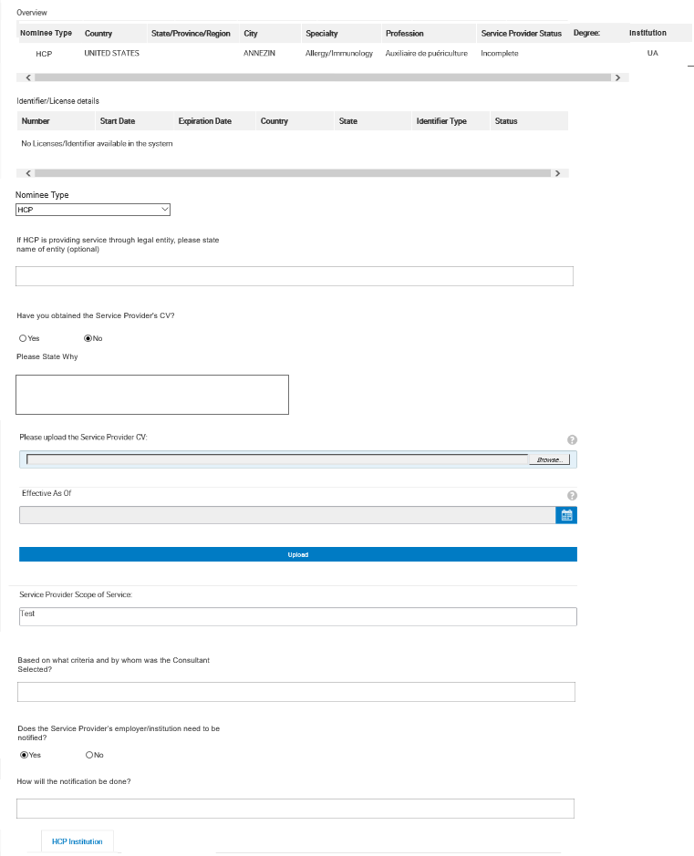

HCO Nomination Form

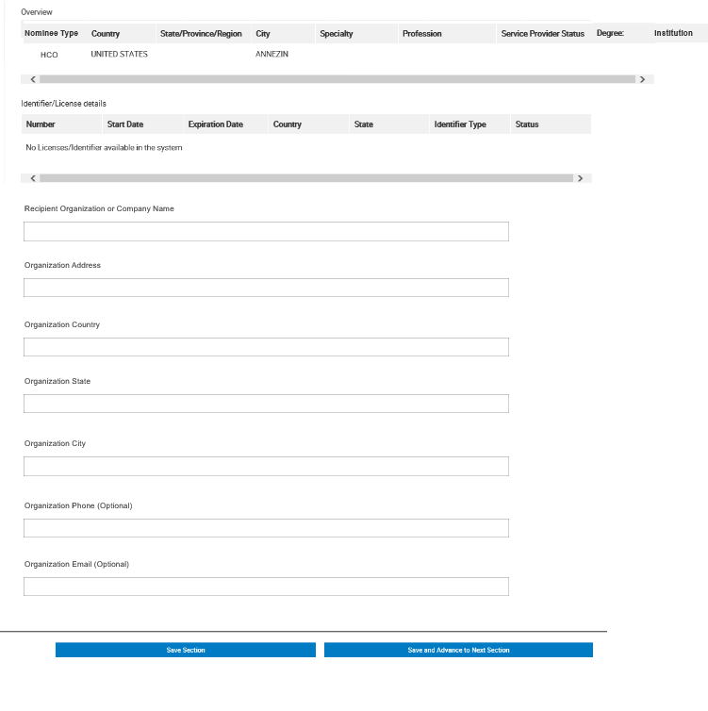

### Fair Market Value

#### Business Requirements Changes

|  |  |
| --- | --- |
| Original BR ID | Description |
|  |  |
|  |  |

#### Technical Customizations

##### Page Level Customizations

|  |  |  |  |  |
| --- | --- | --- | --- | --- |
| Attribute Type | Title | Description | Validation | Customization |
| Data Capture | Will the selected service provider be performing this activity | Remove field- Will the selected service provider be performing this activity | * Field Format: Yes/No Radio button | Remove |
| Data Capture | Total additional Fees/ Overhead to be paid to institution | Remove field- Total additional Fees/ Overhead to be paid to institution | * Field Format: Numeric box | Remove |

##### Technical Specification Changes

|  |  |  |  |
| --- | --- | --- | --- |
| BR ID | TR ID | Section Reference | Customization Description |
|  |  |  |  |

#### Wireframes

### Documents

#### Business Requirements Changes

|  |  |
| --- | --- |
| Original BR ID | Description |
| BR-DOC-01 | Teva will need to link to a document on the Teva network which will describe the necessary documentation to be uploaded for each activity type |
|  |  |

#### Technical Customizations

##### Page Level Customizations

|  |  |  |  |  |
| --- | --- | --- | --- | --- |
| Attribute Type | Title | Description | Validation | Customization |
| Page Element | On-screen help text | Detailed on screen help text will be added on the top of the page | * Field Format: Read-only text | Add |
| Page Element | Required Documentation | Hyperlink will display information regarding the documents required for each request type | * Field Format: Hyper-link | Add |
| Data Capture | Additional Considerations & Documents (optional) | Add a new field - Additional Considerations & Documents | * Field Format: Free text box * Required: No * Field length: 2000 characters | Add |

##### Technical Specification Changes

|  |  |  |  |
| --- | --- | --- | --- |
| BR ID | TR ID | Section Reference | Customization Description |
|  |  |  |  |

#### Wireframes

### Contracting

#### Business Requirements Changes

|  |  |
| --- | --- |
| Original BR ID | Description |
| BR-CON-01 | All Contracting modules and the entire contracting phase will be REMOVED. |
| BR-CON-02 | The request status will remain “Approved” until the day after the Activity Start Date. At this point, the request will be moved to a status of “Pending Reconciliation” and available in the submitter’s inbox. |
| BR-CON-03 | At least 1 HCP needs to be approved, the activity must be approved, and the activity start date must have passed for the activity to move to Pending Reconciliation |
| BR-CON-04 | Remove all mentions of Contracting within Admin module, left hand panel and HCP profile. |
| BR-CON-05 | HCP status when rejected should be “Closed” instead of “Closed – Not Contracted” |

### Post-Event

#### Business Requirements Changes

|  |  |
| --- | --- |
| Original BR ID | Description |
| BR-PE-01 | Requirements will be adjusted so expenses do not need to be entered for an activity to be closed out |
| BR-PE-02 | The closeout requirement will be shifted to the “Are there any other expected expenses” radio button |

#### Technical Customizations

##### Page Level Customizations

|  |  |  |  |  |
| --- | --- | --- | --- | --- |
| Attribute Type | Title | Description | Validation | Customization |
| Data Capture | Please upload Copies of Checks and Expense Receipts | Adjust validation to allow for no expenses to be submitted | * Required: No | Validation Change |
| Data Capture | Are Additional Payments Expected for this Contract? | Adjust validation to close out activity upon selection of “No” | * Required: Yes * Validation: Activity shifts status to “Closed” upon selection of “No” | Validation Change |

##### Technical Specification Changes

|  |  |  |  |
| --- | --- | --- | --- |
| BR ID | TR ID | Section Reference | Customization Description |
|  |  |  |  |

#### Wireframes

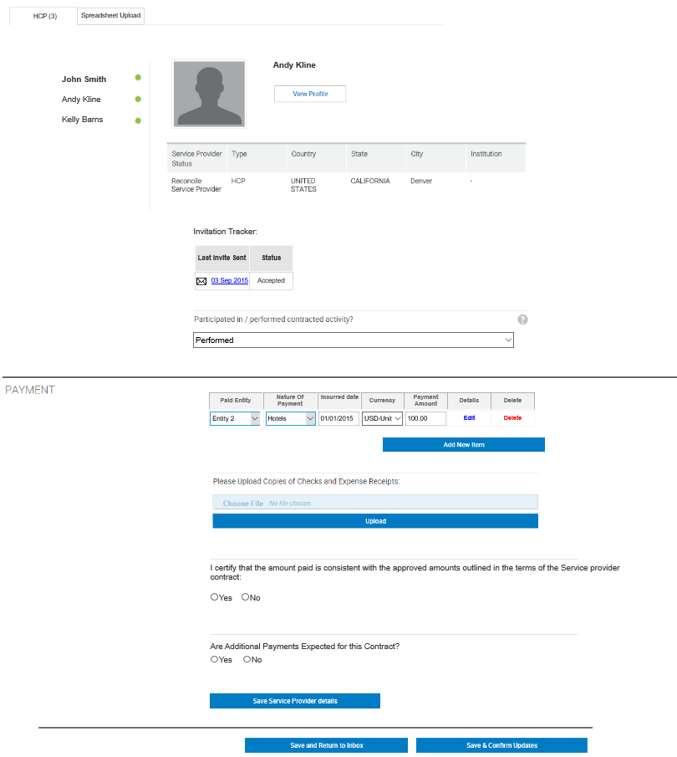

### Approval

#### Business Requirements Changes

|  |  |
| --- | --- |
| Original BR ID | Description |
| BR-APR-01 | Adjust language on page |

#### Technical Customizations

##### Page Level Customizations

|  |  |  |  |  |
| --- | --- | --- | --- | --- |
| Attribute Type | Title | Description | Validation | Customization |
| Data Capture | Activity is in accordance with Teva Policy | Change 2nd checkbox from “Logistics & Travel are in accordance with the Policies…” to “Activity is in accordance with Teva Policy” | * Field Format: Checkbox * Required: No * Validation: None | Modify |
| Data Capture | Service Providers are qualified to provide the proposed services and within Teva’s FMV guidelines | Change 3nd checkbox from “Service Providers are qualified to provide the proposed services and within Teva’s FMV guidelines” to “Activity is in accordance with Teva Policy” | * Field Format: Checkbox * Required: No * Validation: None | Modify |

##### Technical Specification Changes

|  |  |  |  |
| --- | --- | --- | --- |
| BR ID | TR ID | Section Reference | Customization Description |
|  |  |  |  |

#### 4.28.3 Wireframes

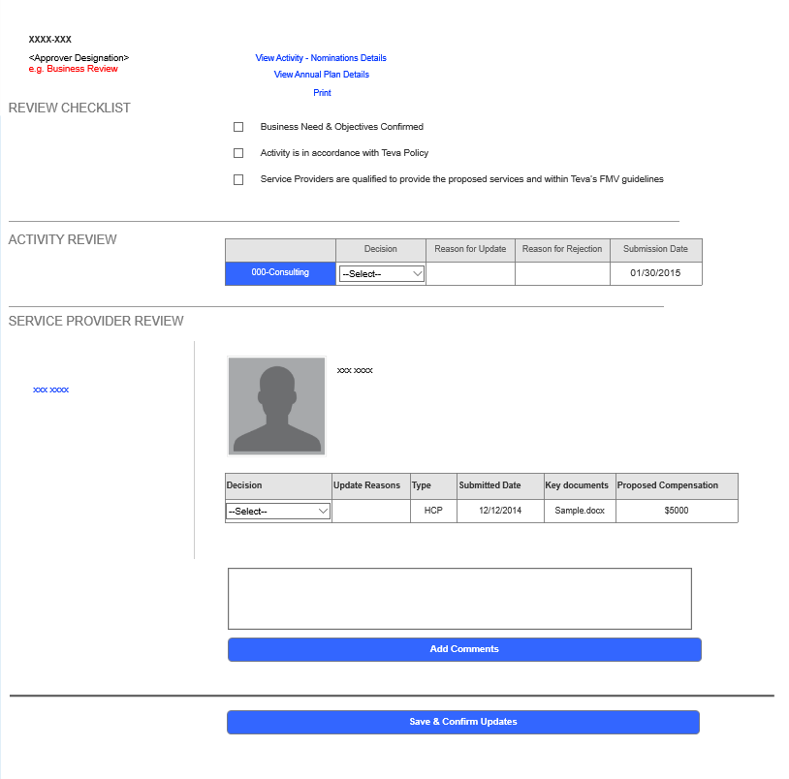

### Appendix A

#### Business Requirements Changes

|  |  |
| --- | --- |
| Original BR ID | Description |
| BR-APP-01 | If a country does not appear in the table below, display all activity categories for selected country. |

#### Activity Category Mapping

|  |  |  |  |  |  |  |  |  |  |  |  |  |  |  |  |  |  |
| --- | --- | --- | --- | --- | --- | --- | --- | --- | --- | --- | --- | --- | --- | --- | --- | --- | --- |
| Activity | US | EU | LATAM | Israel | Kazakhstan | Vietnam | Thailand | South Korea | Malaysia  Singapore | Indonesia | Hong Kong | Turkey | India | Japan | Ukraine | Russia | Australia  New Zealand |
| Fee For Service | Yes | Yes | Yes | Yes | Yes | Yes | Yes | Yes | Yes | Yes | Yes | Yes | Yes | Yes | Yes | Yes | Yes |
| Advisory Board / Expert Meeting | Yes | Yes | Yes | Yes | No | No | No | Yes | Yes | Yes | No | Yes | No | Yes | Yes | Yes | Yes |
| Teva Sponsored Research Activity / Collaborative Research | No | Yes | Yes | Yes | No | No | No | Yes | No | No | Yes | No | No | Yes | No | No | Yes |
| Research Grant | No | Yes | Yes | No | No | No | No | No | No | Yes | No | No | No | Yes | No | No | Yes |
| Sponsorship of 3rd Party Event | Yes | Yes | Yes | Yes | Yes | Yes | Yes | Yes | Yes | Yes | Yes | Yes | Yes | Yes | Yes | Yes | Yes |
| Corporate Membership | Yes | Yes | No | Yes | Yes | No | No | Yes | Yes | Yes | No | Yes | Yes | Yes | Yes | No | No |
| Educational Sponsorship | No | Yes | Yes | Yes | Yes | Yes | Yes | Yes | Yes | Yes | Yes | Yes | Yes | No | Yes | Yes | Yes |
| Educational Grant / Scholarship | No | Yes | Yes | Yes | No | No | Yes | Yes | Yes | Yes | No | Yes | Yes | Yes | Yes | Yes | Yes |
| Scientific / Investigator Meeting | No | Yes | Yes | Yes | No | No | Yes | Yes | Yes | Yes | No | Yes | No | Yes | Yes | Yes | Yes |
| Hospitality | Yes | Yes | Yes | Yes | Yes | Yes | Yes | Yes | Yes | Yes | Yes | Yes | Yes | Yes | Yes | Yes | Yes |
| Items /Gifts | Yes | Yes | Yes | Yes | Yes | Yes | Yes | Yes | Yes | Yes | Yes | Yes | Yes | Yes | Yes | No | No |
| Community Donations | No | Yes | Yes | Yes | No | No | Yes | No | No | Yes | No | Yes | Yes | Yes | Yes | Yes | Yes |
| Equipment / Product Donation | No | Yes | Yes | Yes | No | No | Yes | Yes | No | Yes | No | Yes | Yes | No | Yes | Yes | Yes |
| Speaker Program | Yes | Yes | Yes | Yes | Yes | Yes | Yes | No | Yes | Yes | Yes | Yes | Yes | Yes | Yes | Yes | Yes |
| Site Visit | No | Yes | Yes | Yes | Yes | Yes | Yes | Yes | Yes | Yes | No | N | Yes | Yes | Yes | Yes | Yes |
| Patient Support | Yes | Yes | Yes | Yes | Yes | No | Yes | Yes | Yes | Yes | Yes | Yes | No | Yes | Yes | Yes | Yes |
| Third Party Service Retention | Yes | Yes | Yes | Yes | Yes | Yes | Yes | Yes | Yes | Yes | Yes | Yes | Yes | Yes | Yes | Yes | Yes |
| Market Research | Yes | Yes | Yes | Yes | Yes | Yes | Yes | Yes | Yes | Yes | Yes | Yes | Yes | Yes | Yes | Yes | Yes |

## Non-functional system Requirements

|  |  |
| --- | --- |
| Requirement ID | Description |
| NFR-001 | The system should be able to support 14 languages: English, LATAM Spanish, EU Spanish, Russian, German, French, French Canadian, Brazilian Portuguese, Japanese, Croatian, Bulgarian, Italian, Czech, Polish |
|  |  |
|  |  |
|  |  |
|  |  |

# Revision History

|  |  |  |  |
| --- | --- | --- | --- |
| Version No | Date | Description | Author |
| 1.0 | 1/11/2017 | Initial Draft of Customization Document | Angela Joseph/ Michael Petite |
| 1.1 | 1/17/17 | Update initial draft | Angela Joseph |
| 2.0 | 1/30/2017 | Broke out initial draft to better reflect new approach | Michael Petite |
| 3.0 | 2/8/2017 | Finalizing layout and beginning signoff | Michael Petite/ Patrick Manus |
| 4.0 | 2/9/2017 | Version of document to begin signoff |  |
| 4.2 | 2/15/2017 | Version of document to begin signoff | Michael Petite/Patrick Manus |

# Glossary

<List all the terms used within the document and the respective definition/detailed description here>

|  |  |
| --- | --- |
| Term | Definition |
|  |  |
|  |  |
|  |  |
|  |  |
|  |  |

# Signatures



|  |
| --- |
| Teva Pharmaceuticals |
| By: _____________________________________________ |
| Name: __________________________________________ |
| Title: ____________________________________________ |
| Date: ____________________________________________ |
| |  | | --- | | Teva Pharmaceuticals | | By: _____________________________________________ | | Name: __________________________________________ | | Title: ____________________________________________ | | Date: ____________________________________________ | |  | |